ZSW系列振动给料机
ZSW Series Vibrating Grizzly Feeder
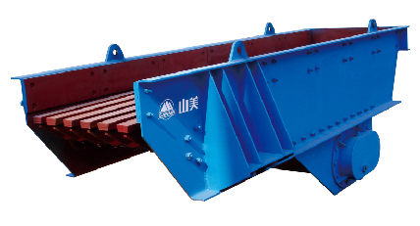

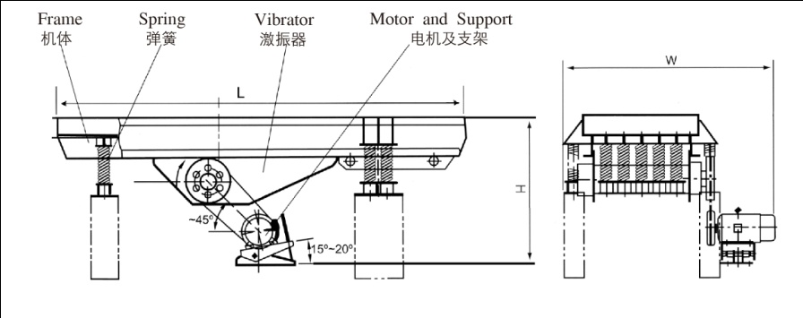

ZSW系列振动给料机主要用于粗碎破碎机前连续、均匀给料、同时可筛分细料、使破碎机能力增大。
ZSW Series Vibrating Grizzly Feeder is mainly used to feed material into the primary crusher homogeneously and continuously. Meanwhile, it can screen the fine material and make the crusher more powerful.

特点及优势 Features and Benefits:

◎ 振动平稳
◎ 特殊栅条设计，可防止物料堵塞
◎ 栅条间隙可调
◎ 可选装变频调速电机，便于控制给料量，无需频繁启动电机。
◎ Minerals and Hard rock Crushing
◎ Aggregates Processing
◎ Slag Processing
◎ Tunnel Crushing

技术参数 Technical Data:
型号  Model | 最大进料粒度  Max Feed Size(mm) | 处理能力  Capacity(t/h) | 电机功率  Motor Power(kw) | 外型尺寸  Overall Dimensions(L×W×H)(mm) | 重量  Weight(kg) | 料槽尺寸  Size of Funnel(mm)
ZSW-380×95 | 500 | 96-160 | 11 | 3882×2224×2121 | 4082 | 3800×950
ZSW-490×95 | 500 | 120-240 | 15 | 4957×2277×2150 | 5004 | 4900×950
ZSW-490×110 | 580 | 120-280 | 15 | 4957×2400×2150 | 5320 | 4900×1100
ZSW-590×110 | 600 | 200-350 | 22 | 6000×2500×2150 | 6130 | 5900×1100
ZSW-600×130 | 750 | 400-560 | 22 | 6082×2580×2083 | 7800 | 6000×1300
ZSW-600×150 | 1000 | 800 | 30 | 6627×2350×3068 | 12110 | 6000×1500
ZSW-600×200 | 1000 | 1200 | 37 | 6436×3853×3014 | 18650 | 6000×2000

