ZK系列直线振动筛
ZK Series Linear Vibrating Screen

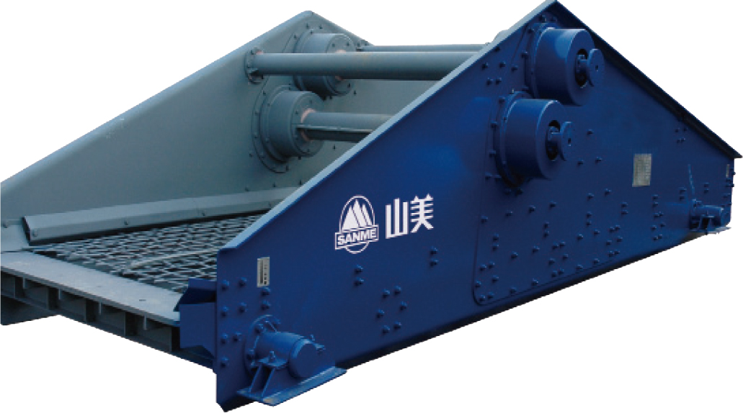

ZK系列直线振动筛是吸收了德国技术制造的高效振动筛，广泛应用于煤炭、治金、电力、建材、轻工等行业,对中、细粒级物料进行干、湿式分级或脱水、脱泥、脱介等。

ZK series linear vibrating screen absorbs Germany technology. With the world advanced technology and unique eccentric structure. It is used in coal , metallurgy, electric power, building materials etc. and suitable for dewater, demud, demedium as well as dry and wet classification to medium and fine materials.

技术参数 Technical Data:
型号  Model | 筛面 Screen Surface |  |  | 给料粒度  Max Feeding  Size(mm) | 处理能力  Capacity  (t/h) | 电机功率  Motor Power  (kw) | 重量  Weight  (kg)
 | 面积  Deck Size(m²) | 筛孔尺寸  Mesh(mm) | 筛网结构  Structural
ZK1022 | 2.25 | 0.25〜50 | 编织、条缝、冲压、 橡胶、聚氨酯筛网  Punched .Polyurethane.Stripped and Seanmed | <250 | 4.5〜90 | 3×2 | 2215
ZK1230 | 3.6 | 0.25〜50 |  | <250 | 7.2〜144 | 4×2 | 2693
ZK1237 | 4.5 | 0.25〜50 |  | <250 | 9.0〜180 | 5.5×2 | 3118
ZK1437 | 5.25 | 0.25〜50 |  | <250 | 12.0〜250 | 5.5×2 | 3210
ZK1445 | 6.3 | 0.25〜50 |  | <250 | 12.6〜252 | 7.5×2 | 4040
ZK1637 | 6 | 0.25〜50 |  | <250 | 12.0〜240 | 5.5×2 | 3552
ZK1645 | 7.32 | 0.25〜50 |  | <250 | 14.4〜280 | 7.5×2 | 4572
ZK1837 | 6.75 | 0.25〜50 |  | <250 | 14.4〜270 | 11×2 | 4995
ZK1845 | 8.1 | 0.25〜50 |  | <250 | 16.2〜324 | 11×2 | 5436
ZK1852 | 9.45 | 0.25〜50 |  | <250 | 18.9〜378 | 11×2 | 5900
ZK2045 | 9 | 0.25〜50 |  | <250 | 16.2〜324 | 11×2 | 5969
ZK2052 | 10.5 | 0.25〜50 |  | <250 | 21.0〜420 | 11×2 | 6472
ZK2060 | 12 | 0.25〜50 |  | <250 | 24.0〜480 | 15×2 | 7558
ZK2445 | 10.8 | 0.25〜50 |  | <250 | 21.6〜432 | 15×2 | 7439
ZK2452 | 12.6 | 0.25〜50 |  | <250 | 25.2〜504 | 15×2 | 8216
ZK2460 | 14.4 | 0.25〜50 |  | <250 | 28.8〜576 | 15×2 | 9235
ZK3045 | 13.5 | 0.25〜50 |  | <250 | 27.0〜540 | 15×2 | 9859
ZK3052 | 15.75 | 0.25〜50 |  | <250 | 31.4〜628 | 22×2 | 9958
ZK3060 | 18 | 0.25〜50 |  | <250 | 17.5〜525 | 22×2 | 11062
ZK3645 | 16.2 | 0.25〜50 |  | <250 | 37.8〜756 | 22×2 | 12289
ZK3652 | 18.9 | 0.25〜50 |  | <250 | 43.2〜846 | 22×2 | 13409
ZK3660 | 21.6 | 0.25〜50 |  | <250 | 43.2〜846 | 22×2 | 14390
ZK3675 | 27 | 0.25〜50 |  | <250 | 54.0〜1080 | 30×2 | 17100
2ZK1022 | 2.25 | 0.25〜50 |  | <250 | 4.5〜90 | 4×2 | 3018
2ZK1230 | 3.6 | 0.25〜50 |  | <250 | 7.2〜144 | 5.5×2 | 3740
2ZK1237 | 4.5 | 0.25〜50 |  | <250 | 9.0〜180 | 7.5×2 | 4460
2ZK1437 | 5.25 | 0.25〜50 |  | <250 | 12.0〜250 | 7.5×2 | 5042
2ZK1445 | 6.3 | 0.25〜50 |  | <250 | 12.6〜252 | 15×2 | 6883
2ZK1637 | 6 | 0.25〜50 |  | <250 | 12.0〜240 | 15×2 | 6919
2ZK1645 | 7.32 | 0.25〜50 |  | <250 | 14.4〜280 | 15×2 | 8654
2ZK1837 | 6.75 | 0.25〜50 |  | <250 | 14.4〜270 | 15×2 | 7951
2ZK1845 | 8.1 | 0.25〜50 |  | <250 | 16.2〜324 | 15×2 | 8116
2ZK1852 | 9.45 | 0.25〜50 |  | <250 | 18.9〜378 | 15×2 | 9061
2ZK2045 | 9 | 0.25〜50 |  | <250 | 16.2〜324 | 15×2 | 9133
2ZK2052 | 10.5 | 0.25〜50 |  | <250 | 21.0〜420 | 22×2 | 10128
2ZK2060 | 12 | 0.25〜50 |  | <250 | 24.0〜480 | 22×2 | 10875
2ZK2445 | 10.8 | 0.25〜50 |  | <250 | 21.6〜432 | 22×2 | 11008
2ZK2452 | 12.6 | 0.25〜50 |  | <250 | 25.2〜504 | 22×2 | 12757
2ZK2460 | 14.4 | 0.25〜50 |  | <250 | 28.8〜576 | 22×2 | 13560
2ZK3045 | 13.5 | 0.25〜50 |  | <250 | 27.0〜540 | 30×2 | 15472
2ZK3052 | 15.75 | 0.25〜50 |  | <250 | 31.4〜628 | 37×2 | 16942
2ZK3060 | 18 | 0.25〜50 |  | <250 | 17.5〜525 | 37×2 | 18253
2ZK3645 | 16.2 | 0.25〜50 |  | <250 | 37.8〜756 | 45×2 | 21042
2ZK3652 | 18.9 | 0.25〜50 |  | <250 | 43.2〜846 | 45×2 | 24040
2ZK3660 | 21.6 | 0.25〜50 |  | <250 | 43.2〜846 | 45×2 | 25400

