YK系列圆振动筛
YK Series Inclined Vibrating Screen

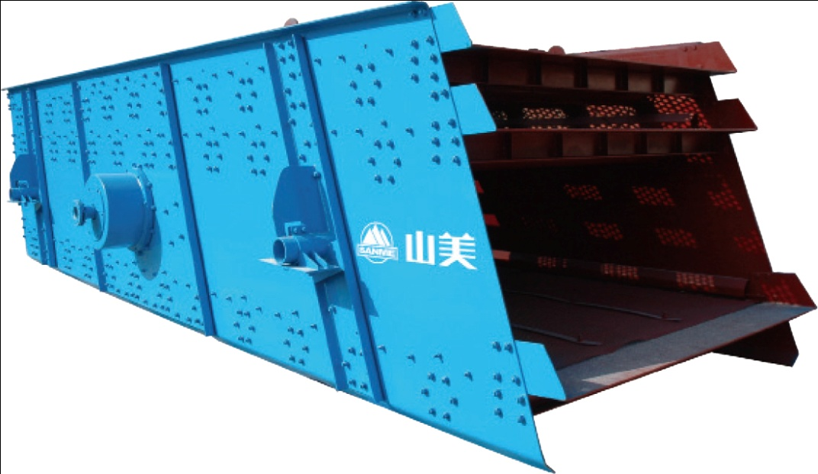
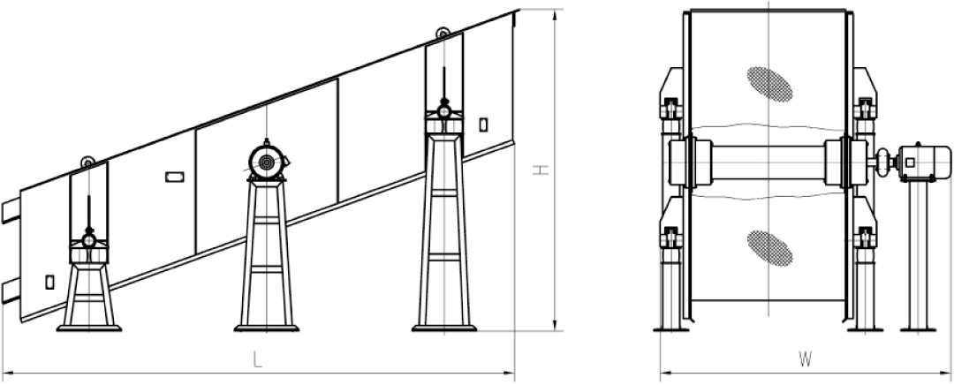

YK系列圆振动筛是我公司吸收德国技术制造的高效振动筛。适宜采石场筛分砂石料，也可用于选煤、选矿、建材、电力及化工等行业。

YK Series Incline Vibrating Screen absorbs Germany technology , and is special designed to sieve different sizes of aggregate. It is also applied to coal dressing, ore dressing, building material, electric power and chemical industries.

特点及优势 Features and Benefits:

◎ 采用块偏心作为激振力，激振力强；
◎ 筛机横梁与筛箱采用高强度螺栓联接，无焊接；
◎ 筛机结构简单，维修方便快捷；
◎ 采用轮胎联轴器，柔性联接，运转平稳；
◎ 筛分效率高，处理量大，寿命长。

◎ High vibrating force with unique eccentric structure.
◎ The beam and case of the screen are connected with high strength bolts without welding.
◎ Simple structure, easy maintenance.
◎ Adopt tire coupling, soft connection makes operation smooth.
◎ High efficiency, high capacity and durable.

技术参数 Technical Data:
型号  Model | 筛网层数  Screen Deck | 筛面倾角  Installation  Slope ( ⁰ ) | 筛网面积  Deck Size(m²) | 振动频率  Vibrating  Frequency(r/min) | 双振幅  Double Amplitude (mm) | 处理能力  Capacity (m³/h) | 电机功率  Motor Power (kw) | 外型尺寸  Overall Dimensions(L×W×H)mm | 重量  Weight(kg)
2YK1224 | 2 | 15 | 2.88 | 970 | 6〜8 | 20〜120 | 5.5 | 2673×2382×2027 | 1750
YK1235 | 1 | 15 | 4.2 | 970 | 6〜8 | 20〜150 | 5.5 | 3710×2464×1450 | 1729
2YK1235 | 2 | 15 | 4.2 | 970 | 6〜8 | 20〜150 | 7.5 | 3705×2393×2339 | 2476
3YK1235 | 3 | 15 | 4.2 | 970 | 6〜8 | 20〜150 | 7.5 | 3621×2521×2581 | 3158
4YK1235 | 4 | 15 | 4.2 | 970 | 6〜8 | 20〜150 | 11 | 3510×2521×2830 | 4160
YK1545 | 1 | 17.5 | 6.75 | 970 | 6〜8 | 22〜150 | 11 | 4904×3044×2179 | 3319
2YK1545 | 2 | 17.5 | 6.75 | 970 | 6〜8 | 22〜150 | 15 | 5042×3090×3165 | 5308
3YK1545 | 3 | 17.5 | 6.75 | 970 | 6〜8 | 22〜150 | 15 | 4972×3090×3395 | 5915
4YK1545 | 4 | 17.5 | 6.75 | 970 | 6〜8 | 22〜150 | 18.5 | 4915×3155×3804 | 7260
YK1548 | 1 | 17.5 | 7.2 | 970 | 6〜8 | 22〜150 | 11 | 5190×3044×2186 | 3319
2YK1548 | 2 | 17.5 | 7.2 | 970 | 6〜8 | 22〜150 | 15 | 5265×3140×3208 | 5284
3YK1548 | 3 | 17.5 | 7.2 | 970 | 6〜8 | 22〜150 | 15 | 5200×3090×3440 | 6186
4YK1548 | 4 | 17.5 | 7.2 | 970 | 6〜8 | 22〜150 | 18.5 | 5200×3155×3849 | 7284
YK1860 | 1 | 20 | 10.8 | 970 | 6〜8 | 32〜350 | 15 | 6302×3365×2992 | 4651
2YK1860 | 2 | 20 | 10.8 | 970 | 6〜8 | 32〜350 | 18.5 | 6020×3455×3756 | 6195
3YK1860 | 3 | 20 | 10.8 | 970 | 6〜8 | 32〜350 | 18.5 | 6020×3455×4180 | 7613
4YK1860 | 4 | 20 | 10.8 | 970 | 6〜8 | 32〜350 | 22 | 5963×3505×4463 | 8650
YK2160 | 1 | 20 | 12.6 | 970 | 6〜8 | 66〜720 | 18.5 | 6302×3730×2992 | 4917
2YK2160 | 2 | 20 | 12.6 | 970 | 6〜8 | 66〜720 | 22 | 5966×3958×3975 | 6856
3YK2160 | 3 | 20 | 12.6 | 970 | 6〜8 | 66〜720 | 30 | 5966×3958×4400 | 9112
4YK2160 | 4 | 20 | 12.6 | 970 | 6〜8 | 66〜720 | 30 | 5966×3958×4780 | 11405
YK2460 | 1 | 20 | 14.4 | 970 | 6〜8 | 75〜750 | 18.5 | 6302×4155×2992 | 5243
2YK2460 | 2 | 20 | 14.4 | 970 | 6〜8 | 75〜750 | 30 | 6027×4308×3975 | 8503
3YK2460 | 3 | 20 | 14.4 | 970 | 6〜8 | 75〜750 | 30 | 6027×4308×4400 | 10411
4YK2460 | 4 | 20 | 14.4 | 970 | 6〜8 | 75〜750 | 30 | 5966×4308×4780 | 12068
2YK2475 | 2 | 20 | 18 | 970 | 6〜8 | 120〜900 | 30 | 7812×4308×4642 | 10709
3YK2475 | 3 | 20 | 18 | 970 | 6〜8 | 120〜900 | 37 | 7718×4393×5033 | 13400
4YK2475 | 4 | 20 | 18 | 970 | 6〜8 | 120〜900 | 45 | 7718×4494×5361 | 15500
YK3060 | 1 | 20 | 18 | 970 | 6〜8 | 200〜900 | 30 | 6302×4943×3108 | 14052
2YK3060 | 2 | 20 | 18 | 970 | 6〜8 | 200〜900 | 37 | 6207×4943×3985 | 17185
3YK3060 | 3 | 20 | 18 | 970 | 6〜8 | 200〜900 | 45 | 6207×4943×4485 | 19200
4YK3060 | 4 | 20 | 18 | 970 | 6〜8 | 200〜900 | 45 | 6207×4943×4785 | 21080

