XS系列洗砂机
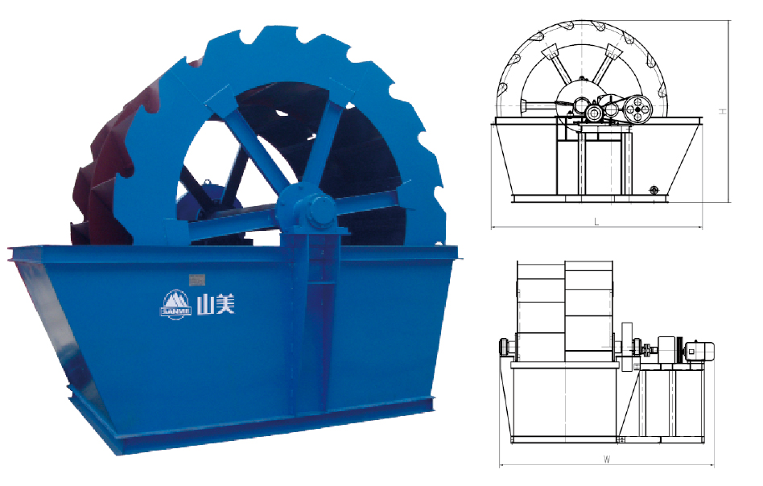
XS Series Sand Washer

XS系列洗砂机是一种轮斗式洗选设备，主要用于建筑砂石料等的洗选脱水。
XS Series Sand Washer is a bucket-typed sand washer, mainly used in washing and dewater sand.

特点及优势 Features and Benefits:

◎ 结构简单，维修便利；
◎ 处理量大，功率消耗低；
◎ 易损件消耗少，使用成本低。
◎ Simple structure, convenient to repair
◎ High processing capacity and low power consumption.
◎ Low wear-parts consumption, low cost.

技术参数 Technical Data:
型号  Model | XS2600 | XS2600 II | XS2800 | XS3200 | XS3600
轮斗直径  Diameter of The Wheel Bucket(mm) | 2600 | 2600 | 2800 | 3200 | 3600
转速  Rotation Rater(r/min) | 2.5 | 2.5 | 1.2 | 1 | 1
最大入料粒度  Maximum Feeding Size(mm) | ≤10 | ≤10 | ≤10 | ≤10 | ≤10
处理量  Processing Capacity(t/h) | 20~50 | 30~70 | 50~100 | 80~120 | 120~180
电机功率  Motor Power(kw) | 5.5 | 5.5 | 7.5 | 11 | 15
外型尺寸  Overall Dimensions(mm) | 3515×2070×2672 | 3515×2270×2672 | 3900×3300×2990 | 3965×4440×3410 | 4355×4505×3810
重量  Weight(kg) | 2500 | 2900 | 3980 | 7270 | 9430

