XL系列洗砂机
XL Series Sand Washer
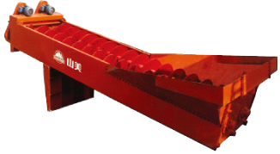
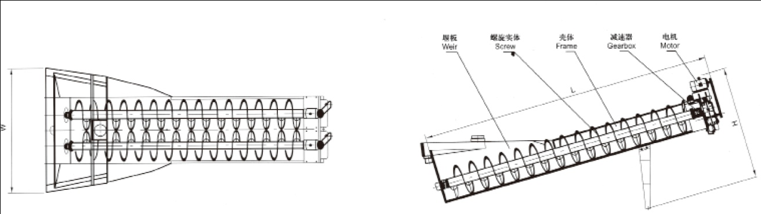

XL系列洗砂机可清洗分离砂石中的泥土和杂物，其新颖的密封结构、可调溢流堰板、可靠的传动装置确保清洗脱水的效果，适用于公路、水电、建筑等行业。
XL Series Sand Washer can wash and separate the soil and foreign material in the sand. Its novel structure, adjustable overflow dam baffle and reliable arrangement can make sure the result of wash.

技术参数 Technical Data:
型号  Model | XL508 | XL610 | XL762 | XL915 | 2XL915 | XL1115 | 2XL1115
螺旋直径  Screw Diameter(mm) | 508 | 610 | 762 | 915 | 915 | 1115 | 1115
槽体长度  Length of Tub(mm) | 6705 | 7225 | 7620 | 7585 | 7585 | 9782 | 9782
最大入料粒度  Max Feed Size(mm) | ≤10 | ≤10 | ≤10 | ≤10 | ≤10 | ≤10 | ≤10
生产能力  Capacity(t/h) | 20 | 40-50 | 50-75 | 100 | 200 | 175 | 350
螺旋转速  Speed of Screw(r/min) | 38 | 32 | 26 | 21 | 21 | 17 | 17
电机功率  Motor Power(kw) | 5.5 | 7.5 | 11 | 11 | 2×11 | 15 | 2×15
耗水量  Water Consumption(t/h) | 6-60 | 6-63 | 9-63 | 10-80 | 20-160 | 20-150 | 40-300
外型尺寸  Overall Dimensions(L×W×H)(mm) | 8000×2343×1430 | 8000×2050×1400 | 8545×2650×3862 | 8500×2810×3600 | 8420×3765×3960 | 10970×3945×4720 | 10970×5250×4720
重量  Weight(t) | 2.67 | 3.80 | 5.23 | 6.27 | 11.11 | 10.18 | 17.94

