VSI系列立式冲击破碎机
VSI Series Vertical Shaft Impact Crusher

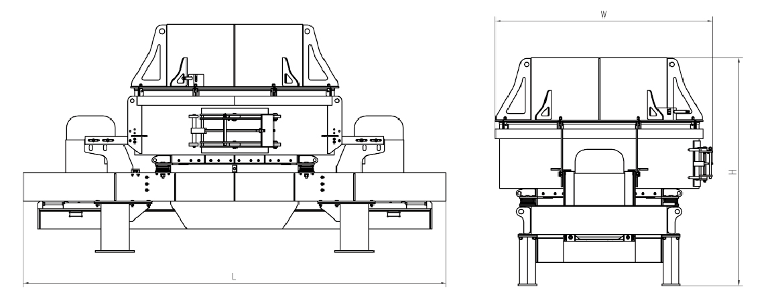
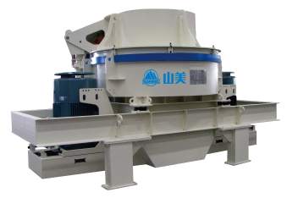

VSI系列立式冲击破碎机是我公司吸收德国先进技术研制并生产的、具有国际先进水平的高性能制砂设备。该机有“石打石”和“石打铁”二种形式。
VSI Series Vertical shaft Impact Crushers, which is high-functioned equipment for making sand and shaping, is researched and produced by our corporation, absorbed with the advanced technology from Germany, and owned advanced world standards. This equipment has two types: rock-on-rock and rock-on-iron.

特点及优势 Features and Benefits:

◎破碎效率高，具有细碎、粗磨功能;
◎结构简单，安装、维修方便，运行成本低;
◎产品粒形优异，呈立方体，针片状含量极低，适宜骨料整形、人工制砂及高等级公路骨料生产;
◎High production of crushing, has the function of fine crushing and rough grinding;
◎Simple structure , easy to set up and repair, low cost in operation.
◎Excellent shape of product, mainly the product shape is cubic with small fraction of elongated flaky particle
shape, suitable for aggregate shaping, manufactured sand.

技术参数 Technical Data:
型号  Model | 最大入料粒度  Max Feed Size(mm) | 叶轮转速  Speed of Rotor(r/min) | 通过量  Capacity(t/h) | 电机功率  Motor Power(kw) | 外型尺寸  Dimensions(L×W×H)(mm) | 重量  Weight(kg)
VSI-3000 | 45(70) | 1700-2000 | 30-60 | 75-90 | 3080×1716×2126 | ≤5310
VSI-4000 | 55(70) | 1400-1620 | 50-90 | 110-150 | 4100×1916×2166 | ≤7840
VSI-5000 | 65(80) | 1330-1530 | 80-150 | 180-220 | 4300×2215×2427 | ≤11200
VSI-6000 | 70(100) | 1200-1400 | 120-250 | 264-320 | 5300×2728×2773 | ≤14590
VSI-7000 | 70(100) | 1000-1200 | 180-350 | 320-400 | 5300×2728×2863 | ≤16580
VSI-8000 | 80(150) | 1000-1100 | 250-380 | 400-440 | 6000×3000×3420 | ≤23450
VSI-9000 | 80(150) | 1000-1100 | 380-600 | 440-630 | 6000×3022×3425 | ≤23980

注：1.上述生产能力是在破碎物料密度为1.6×10³kg/m³时开路循环生产中总吨数。生产能力与破碎物料的物理性能、给料方式、进料粒度及其组成有关；
2.括号内数值适用于低磨蚀性物料。
3.液压开盖和自动润滑装置为选装配置。
Note:1.The capacity is total tons per hour passing through crusher at open circuit when crushing mid-hard material and bulk density with 1.6x10³kg/m³.Capacities are relative to physical character and type of feeding , feeding size and composition and so on.
2.The number in the brackets is applicable to low abrasive material.
3.Hydraulic decap and automatic lubricating device are optional configuration.

