SS Series Fine Sand Collecting System
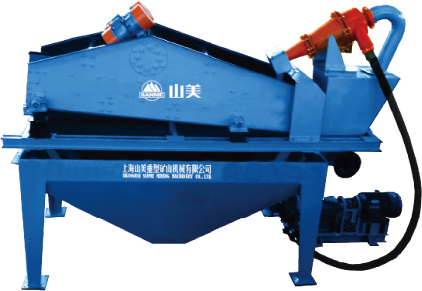
SS系列细砂回收系统

应用于：
机制砂石粉回收
尾矿回收

Application:
Collecting Fine Sand For Manufactured Sand
Collecting Tailing

简介 The brief introduction
目前现有的人工砂生产线，绝大部分采用湿法生产工艺，不论采用何种型式的洗砂机，其最大的缺点是细砂（0.16mm以下颗粒）流失严重，有的甚至流失20％以上，这不但损失产量，而且还严重影响砂子的级配，造成级配不合理，细度模数偏粗，大大降低了机制砂的产品质量。过多的细砂排放，还会造成环境的污染。

The currently existing manufactured sand Production line mostly utilizes a wet production technology and regardless of adopting any style of the sand washer, has the biggest weakness that the fine sand (≤0.16mm) runs off seriously, some even above 20%, which not only decrease the capacity, but also seriously influence the sand gradation that causes the gradation being not reasonable, the fineness module being partially thick and largely lowering the product quality of the manufactured sand. Too many fine sands discharge will also result in environmental pollution.

为解决上述问题，我公司研制了SS系列细砂回收系统，该系统是吸收国外的先进技术，结合我国的实际情况而设计的具有世界先进水平的细砂回收装置，广泛应用于砂石骨料加工系统、玻璃原料加工系统、人工制砂生产线、选煤厂粗煤泥的回收及环保工程（泥浆净化等）等，可有效的解决细砂回收问题。

In order to solve the above problems, we specially research and manufacture the SS Series Fine Sand Collecting System, which is designed on the base of absorbing abroad advanced technology, together with our practical situation and comes up to the advanced world standard. It is widely utilized in quarry, the processing system of glass raw material, the manufactured sand production line, the coarse slime recovery of coal preparation plant, the environmental protection project (mud cleaning etc.) and so on, and can solve fine sand collecting problems.

工作原理 Working Principle
1、结构：由电机、渣浆泵、旋流器、直线振动筛、清洗槽、返料箱等组成。
Structure: It is mainly composed of motor, residue slurry pump, cyclone, vibrating screen, rinse tank and recycling box.

2、工作过程: 泵将砂水混合物输送至旋流器，离心分级浓缩的细砂经沉砂嘴提供给振动筛，经振动筛脱水后,细砂与水有效分离，少量细砂、泥等经返料箱再回到清洗槽，清洗槽液面过高时，经出料口排出.直线振动筛回收物料重量浓度为70%-85%。调节细度模数可通过改变泵转速、改变砂浆浓度、调节溢流水量、更换出砂嘴来实现。从而完成清洗、脱水和分级三种功能。
2. Working Procedure: The compound of sand and water is transported to the cyclone by pump, and the fine sand after centrifugal classification concentration is provided to the vibrating screen by the grit setting mouth, after vibrating screen dewater, the fine sand and water are effectively separated. Through the recycling box, little fine sand and mud return again to the rinse tank, and then they are exhausted from the discharge hole when the rinse tank liquid level is too high. The material weight concentration recovered by the linear vibrating screen is 70%- 85%. Adjusting the fineness module can be realized by changing the pump rotating speed and pulp concentration, regulating the overflow water yield and replacing the grit mouth, thus achieves its three functions—washing, dewater and classification.
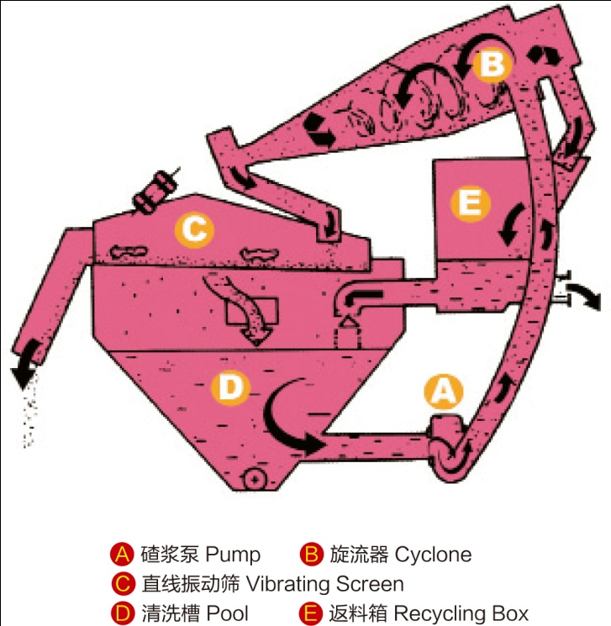

特点及优势 Features and Advantages
- 传统人工砂湿法加工工艺中，人工砂的洗泥、脱水采用螺旋洗砂机，人工砂中细砂的流失几乎不能控制。采用该细砂回收装置，可以有效降低细砂的流失量，使其控制在5～10％之内。很好地解决了人工骨料加工系统中出现的成品砂细度模数偏高、石粉含量偏低的难题。
The sand washer is utilized to wash mud and dewater of the manufactured sand in the traditional wet processing technology, but the manufactured sand losses (especially the fine sand) almost can not be controlled. However, Utilizing the SS Series Fine Sand Collecting System can effectively reduce the fine sand loss , controlling it in the scope of 5～10% and successfully solves the problems, which refers to the fineness module of finished sand being partially high，while the power content be low in aggregate processing system.

2、振动筛采用聚氨酯筛网，聚氨酯筛网较其它类型筛网寿命更长，且不易堵孔。
The vibrating screen adopts polyurethane mesh, which compared with other ones, has longer life and uneasy to be blocked.
3、旋流器内衬聚氨酯，提高了整个装置的使用寿命，可顺利完成料浆浓缩、液体澄清等工作。
The cyclone is lined with polyurethane, which lengthens the whole device service life and can smoothly finished the work of condensing slime and clearing the liquid etc.

4、最大可回收排放总量中85%的细颗粒物料，具有其他设备无可比拟的技术和经济优势。
The maximum recovering quantity of fine particle materials from the total discharge amount is 85%, so it has unsurpassed technology and economic advantages compared with other equipments.

5、细颗粒得到充分回收，减少了沉淀池的工作量，降低了沉淀池的清理成本；
The fine sand is recovered sufficiently, which reduces the sedimentation basin workload and lowers its disposal cost.

6、减少了细料自然堆放时间，可直接转运、供应市场。
Lessening natural stock time of the fine sand and able to transfer them directly and supply the market.

7、可根据用户的不同要求，设计相应的解决方案。
We can design corresponding solutions according to our customers’ different requirements.

技术参数 Technical Data
型号  Model | 泵Pump |  |  | 旋流器规格  Cyclone (mm) | 脱水筛 Vibrating Screen |  |  | 处理量  Capacity(m³/h)
 | 功率  Power(kw) |  | 尺寸  Size(inch)
 |  |  |  |  | 型号  Model | 面积  Deck Size(m²) | 功率  Power (kw)
SS-06-300 | 7.5 | 2” |  | 300 | 0.6×1.5 | 0.9 | 2x0.75 | 10-40
SS-08-300 | 15 | 2.5” |  | 300 | 0.8×2.25 | 1.8 | 2x1.5 | 40-80
SS-10-350 | 18.5 | 3” |  | 350 | 1.0×2.25 | 2.25 | 2x1.5 | 70-120
SS-12-550 | 30 | 5” |  | 550 | 1.2×3.0 | 3.6 | 2x2.2 | 100-200
SS-14-750 | 37 | 6” |  | 750 | 1.4×3.0 | 4.2 | 2x3 | 180-343
SS-14-750II | 45 | 6” |  | 750 | 1.4×3.0 | 4.2 | 2x3 | 230-420
SS-16-750 | 55 | 8” |  | 750 | 1.6×3.0 | 4.8 | 2x4 | 250-500
SS-16-2×650 | 55 | 10” |  | 2x650 | 1.6×3.75 | 6.0 | 2x5.5 | 300-500
SS-18-2×750 | 75 | 10” |  | 2x750 | 1.8×3.75 | 6.75 | 2x7.5 | 350-600
注：最大进料粒度≤5mm Note: Max Feed Size ≤5mm

成功案例 Project Example
成都彭州砂石厂，原采用一台螺旋洗砂机清洗机制砂，所生产的机制砂细度模数偏粗，主要原因是在洗砂过程中，细砂及石粉流失严重；原螺旋洗砂机排出的废水为100T/小时左右，细砂含量约为15-20%，螺旋洗砂机排出的清洗水直接进入沉淀池，因清洗水中细砂含量大，沉淀池很容易淤塞，为解决上述问题，该厂于2006年购置了一台型号为SS－10－350的细砂回收系统，对洗砂机的排放水进行预处理，回收清洗水中的细砂及石粉。采用细砂回收系统后，洗砂机排放水经细砂回收系统清洗槽－渣浆泵－旋流器（浓缩、分级浓度约为55-65%）－直线振动筛（脱水、脱泥）－成品细砂－胶带输送机－成品料堆，每小时可回收细砂14吨左右。

Chengdu Pengzhou Quarry Co., Ltd. formerly utilized one set of screw sand washer to clean manufactured sand and produced the manufactured sand with fineness module being partially thick. The main reason is that the fine sand and stone power run off seriously in the sand washing process. The powder content is about 15-20%, and the waste water discharged by the screw sand washer is about 100t/h, which directly enters the sedimentation basin, because of the large amount of fine sand, the sedimentation basin can be blocked easily. In order to solve the above problems, they bought one set of SS-10-350 fine sand collecting system in 2006 to pre-dispose exhausted water from the sand washer and recycle the fine sand and stone power in the waste water. After using this system, they can recover 14t/h fine sand from the waste water discharged by the sand washer through the fine sand collecting system with the process rinse tank--slurry pump--cyclone ( the density of concentration and classification is 55-65%)--linear vibrating screen ( hydrate water and slime)-- finished fine sand-- belt conveyor--finished products stock.
该细砂回收系统成功运行后，不仅大大改善了机制砂成品质量，而且提高了生产线中机制砂的产量，创造了可观的经济效益，客户非常满意。
现场数据表明，该细砂回收系统各项技术指标达到设计要求，使用效果超过客户的预期。

After the fine sand collecting system operates successfully, it not only greatly improves the manufactured sand quality, but also raises the manufactured sand yield in the production line, brings considerable economic profit and satisfies our customer very well.
The data from the site show that all technical data of the fine sand collecting system comes up to the design requirements and the operation effects are beyond customers’ expectation.

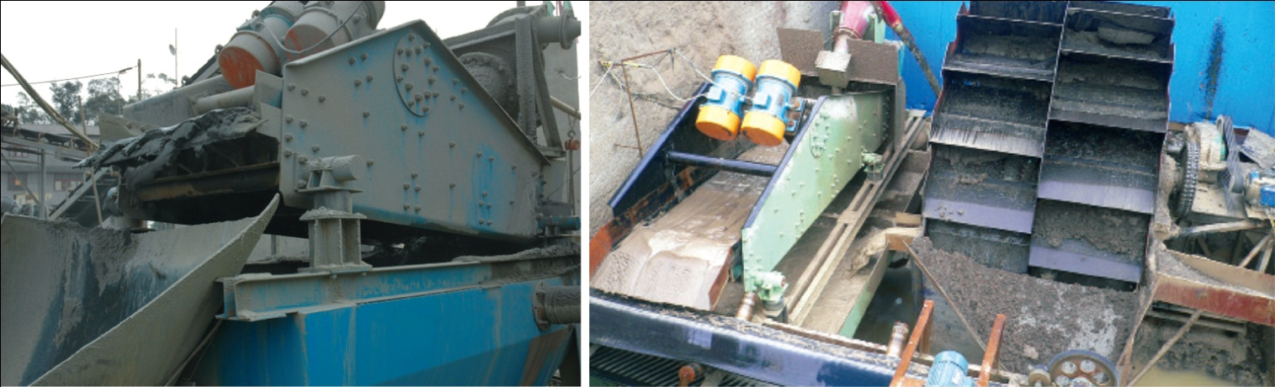

经济效益分析 Economic Benefit Analysis
螺旋洗砂机排出的废水中细砂含量约为15％左右（15吨/小时），经细砂回收系统处理后，由细砂回收系统排放的废水中石粉含量不到3%,细砂回收效率达到83%(15吨/小时×83%=12.45吨/小时)。

The fine sand content is about 15% (15t/h) in the waste water exhausted from the screw sand washer. But after disposed by the fine sand collecting system, the power content is less than 3% and its recovery ratio comes up to 83%(15t/h×83%=12.45t/h).

生产线每天按工作八小时计算：12.45吨/小时×8小时=99.6吨/天；
Calculating according to the working time for eight hours everyday:12.45t/h×8h=99.6t/day.

一年按工作260天计算：99.6吨/天×260天=25896吨/年；
Calculating by 260 working days a year: 99.6t/day×260days=25896t/year；

成品砂按35元/吨计算：25896吨×35元/吨=90.636万元；
The price of the sand is ￥35 per ton: 25896t×￥35/t=￥906,360
除去设备运行和维护费用约10万元/年，一年增加约80万元收益。
You can increase the profit by ￥800,000 every year after subtracting ￥100,000/year of the operation and maintenance cost.

同时，细砂得到充分回收，减少了沉淀池的工作量，降低了沉淀池的清理成本。
Meanwhile, the fine sand is recovered sufficiently, which reduces the sedimentation basin workload and lowers its disposal cost.

最大可回收排放总量中85%的细颗粒物料,
具有其他设备无可比拟的技术和经济优势!
The maximum recovering ratio of fine particle from the total discharge amount is 85%, so it has unsurpassed technology and economic advantages compared with other equipments.

