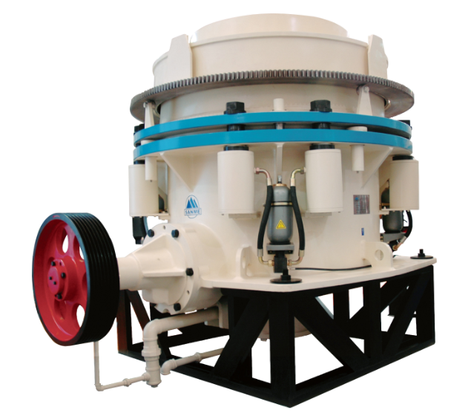
SMH系列液压圆锥破碎机
SMH Series Cone Crusher
SMH系列液压圆锥破碎机是经过吸收世界先进破碎技术
研制出的具有先进水平的圆锥破碎机，广泛应用于冶金、
建筑、水电、交通、化工、建材工业中，适合破碎坚硬、
中等硬度以上的各种矿石和岩石 。

SMH series hydraulic cone crusher get to world
advanced level, is designed and made through
absorbing world advanced crushing technology.
It is widely used in metallurgical, aggregate,
building material industries, it is suitable for crushing
varies of hard and above mid hard ores and rocks.

特点及优势 Features and Benefits:

◎ 结构合理，破碎原理及技术参数先进，运转可靠，运行成本低；
◎ 具有大破碎力，生产效率高，产量高；
◎ 液压系统方便可靠，能提供安全有效的过载保护；
◎ 多种破碎腔，适应大范围产品粒度要求；
◎ 采用液压调整、液压清腔设置，自动化程度大为提高。

◎ Reasonable structure, advanced crushing principle and technical data, reliable work and low cost.
◎ Strong crushing ability, high efficiency productivity, high capacity.
◎ Hydraulic system is reliable, provide safe and effective overload protection.
◎ Types of crushing cavity are for wide range of product size requirement.
◎ Use hydraulic adjustment and hydraulic clean cavity setting, much increase automation.

主要零件 Main Components

标准型液压圆锥破碎机 / Standard Head Cone Crushers
技术参数 Technical Data
型号  Model | 最大给料尺寸  Max Feeding  Size  (mm) | 排矿口范围  Discharge  Range  (mm) | 电机功率  Motor Power  (kw) | 生产能力（吨／小时）—开路循环 闭边排矿口  Capacity(t/h)——open circuit,closed discharge(mm)
 |  |  |  | 9 | 13 | 16 | 19 | 22 | 26 | 32 | 38 | 51 | 63 | 76 | 89
SMH120C | 160 | 22-32 | 75-90 |  |  |  |  | 120 | 130 | 150
SMH120M | 130 | 13-26 |  |  | 65 | 85 | 100 | 120 | 130
SMH120F | 50 | 9-19 |  | 40 | 60 | 80 | 90
SMH180C | 180 | 22-32 | 132-160 |  |  |  |  | 185 | 195 | 215
SMH180M | 140 | 13-32 |  |  | 90 | 115 | 135 | 160 | 180 | 200
SMH180F | 60 | 9-22 |  | 60 | 80 | 100 | 120 | 140
SMH250C | 260 | 26-51 | 160-220 |  |  |  |  |  | 250 | 290 | 340 | 395
SMH250M | 150 | 16-38 |  |  |  | 125 | 140 | 165 | 220 | 275 | 330
SMH250F | 80 | 9-22 |  | 70 | 90 | 115 | 130 | 150
SMH  350EC | 315 | 38-64 | 250-280 |  |  |  |  |  |  |  | 555 | 649 | 766
SMH350C | 230 | 26-64 |  |  |  |  |  |  | 366 | 430 | 468 | 929 | 657
SMH350M | 205 | 22-52 |  |  |  |  |  | 266 | 299 | 348 | 393 | 451
SMH350F | 180 | 16-38 |  |  |  | 188 | 212 | 234 | 267 | 305 | 337
SMH  550EC | 450 | 38-89 | 400 |  |  |  |  |  |  |  | 890 | 1179 | 1380 | 1475 | 1566
SMH550C | 350 | 31-76 |  |  |  |  |  |  |  | 800 | 850 | 1100 | 1288 | 1398
SMH550M | 320 | 25-63 |  |  |  |  |  |  | 612 | 735 | 815 | 990 | 1137
SMH550F | 268 | 19-52 |  |  |  |  | 376 | 412 | 500 | 620 | 725 | 867

短头型液压圆锥破碎机 / Stort Head Cone Crushers
技术参数 Technical Data
型号  Model | 最大给料尺寸  Max Feeding  Size  (mm) | 排矿口范围  Discharge  Range  (mm) | 电机功率  Motor Power  (kw) | 生产能力（吨／小时）—开路循环 闭边排矿口  Capacity(t/h)——open circuit,closed discharge(mm)
 |  |  |  | 3 | 5 | 6 | 9 | 13 | 16 | 19 | 22 | 26 | 32 | 38
SMH120DC | 70 | 6-19 | 75-90 |  |  | 59 | 68 | 96 | 110 | 130
SMH120DM | 51 | 5-16 |  |  | 45 | 59 | 68 | 96 | 110
SMH120DF | 35 | 3-13 |  | 30 | 45 | 50 | 65 | 90
SMH180DC | 70 | 6-19 | 75-90 |  |  | 72 | 90 | 108 | 131 | 158
SMH180DM | 51 | 5-16 |  |  | 68 | 76 | 95 | 118 | 145
SMH180DF | 35 | 3-13 |  |  | 70 | 82 | 95 | 120
SMH250DC | 89 | 9-22 | 160-220 |  |  |  | 100 | 120 | 145 | 175 | 210
SMH250DM | 70 | 6-16 |  |  |  | 82 | 105 | 130 | 160
SMH250DF | 54 | 5-16 |  |  | 80 | 90 | 110 | 135 | 160
SMH  350DEC | 133 | 13-25 | 250-280 |  |  |  |  | 280 | 310 | 340 | 370 | 390
SMH350DC | 133 | 10-25 |  |  |  |  | 210 | 280 | 310 | 340 | 370 | 390
SMH350DM | 89 | 6-19 |  |  |  | 130 | 168 | 215 | 260 | 290
SMH350DF | 70 | 6-13 |  |  |  | 130 | 168 | 215
SMH  550DEC | 203 | 16-25 | 400 |  |  |  |  |  | 510 | 600 | 630 | 680 | 720 | 750
SMH550DC | 178 | 13-25 |  |  |  |  |  | 455 | 488 | 552 | 600 | 620 | 698
SMH550DM | 133 | 10-19 |  |  |  |  | 355 | 420 | 460 | 530 | 545 | 580
SMH550DF | 105 | 6-16 |  |  |  | 220 | 310 | 375 | 428 | 482 | 497
拆卸外形尺寸和重量 Clearance Dimensions and Weight
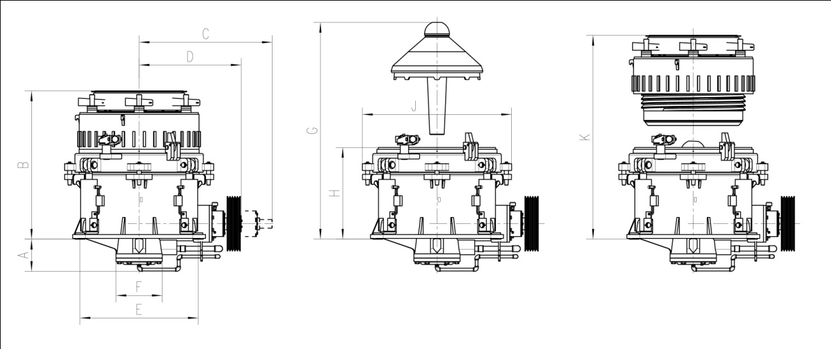

技术参数 Technical Data
拆卸外形尺寸和重量  Clearance Dimensions and Weight |  | 单位  Unit | 破碎机规格 Crusher Specifications
 |  |  | SMH120 | SMH180 | SMH250 | SMH350 | SMH550
机架底面至底部油管最低点  Distance between rack bottom and oil pipeline at the bottom | A | mm | 377 | 263 | 593 | 850 | 1020
机架底面至给料斗顶部  Distance between rack bottom and hopper top | B | mm | 1737 | 1810 | 2119 | 2496 | 3290
拆卸传动轴部所需水平空间  Horizontal space at the time of drive shaft disassembling | C | mm | 1773 | 1833 | 2396 | 3510 | 4420
破碎机中心线至传动轴外端面  Distance between centre line of crusher and outside end surface of drive shaft | D | mm | 1191 | 1191 | 1566 | 2465 | 2968
地脚螺钉位置尺寸  Size of bolt position | E×E | mm | 1380 | 1380 | 1766 | 2260 | 2490
底盖直径  Diameter of bottom cap | F | mm | 540 | 400 | 686 | 800 | 927
拆卸主轴部所需高度空间  Vertical space at the time of main axis disassembling | G | mm | 2538 | 2233 | 3353 | 4065 | 5860
机架底面至支撑套顶部  Distance between rack bottom and top of supporting ring | H | mm | 1074 | 1147 | 1324 | 1705 | 2431
支撑套最大直径  Max diameter of supporting ring | J | mm | 1740 | 1740 | 2258 | 3620 | 3721
拆卸调整套部所需高度空间  Vertical space at the time of adjustment set disassembling | K | mm | 2387 | 2460 | 2937 | 3755 | 4576
破碎机总重  Total Weight |  | kg | 12500 | 13500 | 24200 | 45850 | 86700

不同排料口（mm）条件下，产品粒度特性（通过方孔筛mm的百分比%）
Product Gradation Table (%passing through square mesh depending on the setting)
排  矿  口  c.s.s.  筛  孔  mesh | 6 | 8 | 10 | 13 | 16 | 19 | 22 | 25 | 28 | 32 | 38 | 45 | 51
2 | 38 | 25 | 21 | 15 | 11 | 10 | 9 | 7 | 5 | 4 | 3 | 3 | 2
4 | 64 | 45 | 38 | 33 | 25 | 20 | 15 | 13 | 10 | 8 | 6 | 5 | 2
6 | 77 | 62 | 56 | 41 | 34 | 29 | 23 | 18 | 14 | 11 | 7 | 6 | 5
8 | 92 | 79 | 69 | 55 | 42 | 35 | 27 | 22 | 17 | 14 | 10 | 9 | 8
10 | 99 | 90 | 78 | 66 | 51 | 45 | 35 | 30 | 25 | 18 | 16 | 13 | 10
13 | 100 | 95 | 88 | 78 | 62 | 55 | 43 | 36 | 28 | 23 | 18 | 15 | 14
16 |  | 100 | 96 | 88 | 77 | 65 | 53 | 46 | 37 | 29 | 23 | 20 | 17
19 |  |  | 100 | 95 | 85 | 76 | 67 | 55 | 44 | 37 | 27 | 23 | 20
22 |  |  |  | 100 | 92 | 83 | 76 | 65 | 53 | 45 | 35 | 28 | 23
25 |  |  |  |  | 100 | 92 | 87 | 75 | 62 | 53 | 39 | 33 | 27
32 |  |  |  |  |  | 100 | 95 | 86 | 78 | 68 | 52 | 43 | 36
38 |  |  |  |  |  |  | 100 | 96 | 88 | 82 | 64 | 55 | 50
51 |  |  |  |  |  |  |  | 100 | 96 | 90 | 84 | 75 | 64
63 |  |  |  |  |  |  |  |  | 100 | 99 | 95 | 86 | 76
75 |  |  |  |  |  |  |  |  |  | 100 | 100 | 97 | 88
100 |  |  |  |  |  |  |  |  |  |  |  | 100 | 100

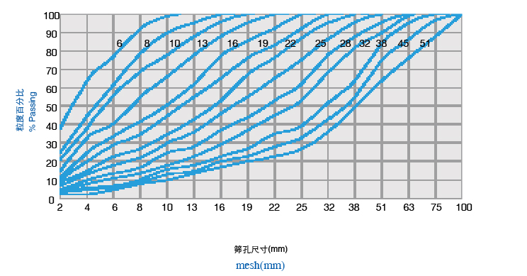
粒度分布曲线 Gradation Curves

注：表中粒度与给料粒度、破碎腔型、含水量、物料密度、可碎性、含泥量等因素有关。
Note: The gradation shown are depend on the feed gradation, the crushing chamber, the material density, the material mud content, its moisture and its crushability.

