SMG系列液压圆锥破碎机
SMG Series Cone Crushers
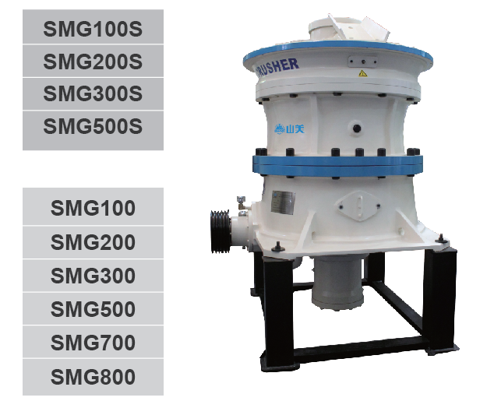
SMG系列液压圆锥破碎机是具有世界先进水平的圆锥破碎机，不仅具有高可靠性，而且破碎效率高、运行成本低、产品粒形好等优点，广泛应用于矿山和砂石骨料行业，适合破碎坚硬、中等硬度以上的各种矿物和岩石，可以应用于物料的中碎、细碎及制砂。
SMG series cone crusher is an advanced technology of cone crusher in the world, not only provides the features of high reliability, but also with the features of high crushing efficiency, low operating cost, good shape of end products. It is widely applied in the field of mining and aggregate processing industries and it is suitable for crushing hard and mid-hard ore and rock, meanwhile, it can be used for secondary crushing, tertiary crushing and sand making.
特点及优势 Features and Benefits:
- 优化的腔型 更高的产量 更佳的产品质量 Optimized cavity, higher capacity and better quality

SMG系列液压圆锥破碎机在总结了各种破碎腔型的优点基础上，在经历理论的分析和实践的检验情况下，设计出的SMG系列液压圆锥机具有多种破碎腔型可供选择，通过选择合适的破碎腔型及偏心距，可以最大限度的满足客户的生产要求，实现高产量。在挤满给料情况下，能够实现层压破碎，使最终的产品粒形更优、立方体颗粒含量更多。
Based on all advantages of each crushing cavity, and through theoretical analysis and practical examination, SMG series cone crusher is designed for optional variety of cavities. By selecting suitable cavities and eccentricity, it ensures the producing demand of customer in maximum and realizes high capacity. Laminated crushing function can be fully realized when full load, which contributes to good shape of end product with more cubic particles.
2.易损件消耗少 运行成本低 Resistant wear part consumption and low operating cost

由于采用液压调整排矿口，可以及时、方便的调整排矿口，使破碎机在挤满给料状态下工作，降低易损件的消耗，降低运营成本。
The discharging open can be adjusted timely and conveniently with hydraulic adjusting design, which realizes full load operation, lowers wear parts consumption and reduces operating cost.

3.粗细破碎转换方便 Easy cavities exchange

因为破碎机的主体结构相同，所以只需通过更换衬板就可以获得不同的破碎腔型，可以满足粗细碎的不同工艺要求。
Due to the same body structure, we can get different crushing cavity by changing liner plate to fulfill the various processing for coarse and fine crushing.

4.先进的液压技术使操作简单和维修方便 Advanced hydraulic technology offers easy operation and maintenance

由于采用了先进的液压技术，可有效实现过载保护，简化了破碎机结构，减轻了重量。当有不可破碎的异物进入破碎腔时，液压系统可以平缓的释放冲击力以保护主机，并在异物通过后恢复到原来的排料口，避免出现闷车的现象。如果破碎机在负载的情况下停机，液压缸能提供较大的清腔行程，帮您快速地清理掉破碎腔中的石料，并可以恢复到原来的排料口，不需要您再次调整排料口。相对于传统的弹簧式圆锥破碎机来说，更加安全、更加快捷，最大限度的节约了您的停机时间。
Due to adopting advanced hydraulic technology, overload protection can effectively be realized, which simplify the structure of crusher and reduces its weight. When some unbreakable foreign materials enter the crushing cavity, the hydraulic systems can release the impact force gently to protect the mainframe and the discharge opening will retrieve after the foreign materials are discharged, avoiding extrusion failure. If cone crusher is stopped with load, the hydraulic cylinder of double functions clears the materials in the cavity with the maximum clearing stroke and the discharge opening will go back to the original position automatically and save you from readjusting. Hydraulic cone crusher is much safer, quicker and saves you more down time compared with traditional spring cone crusher.

所有的维护和检查都可以从破碎机的上部来完成，使维修更方便。
All maintenance and inspection can be fulfilled on the top of crusher, which ensures easy maintenance.

5.大给料口设计 Large feeding opening design

SMG系列液压圆锥破碎机的S机型采用大给料口设计，可以和前段的粗碎颚式破碎机或旋回破碎机形成更好的配套，提高破碎系统的处理能力；在加工河卵石时，可以替代颚破作为粗碎。
Large feeding opening design is adopted by S type SMG series cone crusher to provide good combination with primary jaw crusher or gyratory, which greatly improves the crushing capacity. While processing gravels, it can replace jaw crusher and be used as primary crusher.

SMG系列中碎液压圆锥破碎机主要部件
Main Components of SMG Series Secondary Cone Crushers

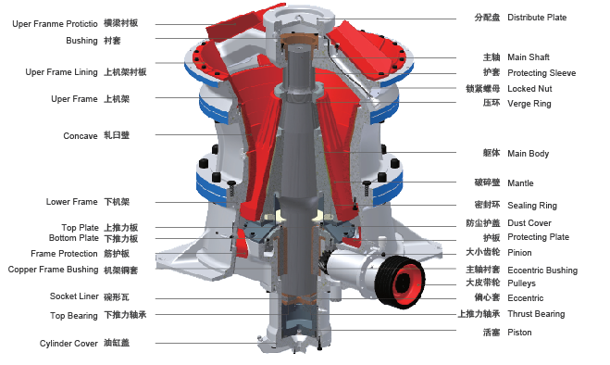

技术参数 Technical Specifications:
型号  Model | SMG100S | SMG200S | SMG300S | SMG500S
电机功率  Power (kw) | 90 | 160 | 250 | 315
冲程  Stroke(mm) | 16-25 | 18-36 | 18-40 | 18-40
维修时最大起重量  Max lift during maintenance (kg) | 2850 | 4750 | 8500 | 14200
总重量  Total weight (kg) | 7500 | 12000 | 22500 | 36300
生产能力Capacities(t/h) | 70-165 | 105-330 | 219-586 | 290-860

SMG系列细碎液压圆锥破碎机主要部件
Main Components of SMG Series Tertiary Cone Crushers

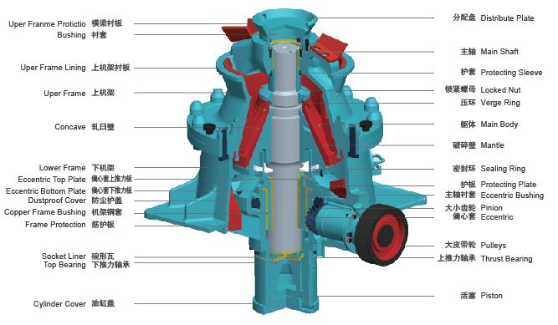
技术参数 Technical Specifications:
型号  Model | SMG100 | SMG200 | SMG300 | SMG500 | SMG700 | SMG800
电机功率  Moter power (kw) | 90 | 160 | 250 | 315 | 520 | 600
冲程  Stroke (mm) | 16-25 | 18-40 | 25-40 | 25-45 | 30-50 | 30-50
维修时最大起重量  Max lift during maintenance (kg) | 1650 | 2850 | 5150 | 8600 | 15600 | 23000
总重量  Total weight (kg) | 5700 | 9500 | 17500 | 28000 | 53000 | 75000
生产能力Capacities(t/h) | 30-120 | 63-215 | 95-396 | 175-638 | 350-1391 | 387-1809

SMG系列液压圆锥破碎机拆卸外形尺寸
Clearance Dimensions of SMG Series Cone Crushers
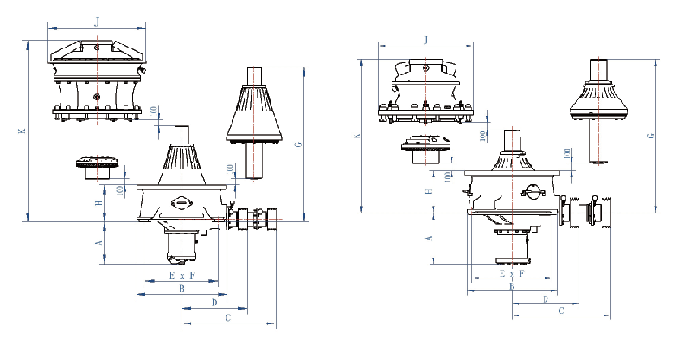
Dimensions | SMG100S | SMG200S | SMG300S | SMG500S | SMG100 | SMG200 | SMG300 | SMG500 | SMG700 | SMG800
A | 712 | 734 | 812 | 920 | 712 | 734 | 812 | 920 | 1090 | 1200
B | 1250 | 1588 | 1980 | 2320 | 1250 | 1588 | 1980 | 2320 | 2770 | 3040
C | 1366 | 1652 | 2109 | 2433 | 1366 | 1652 | 2109 | 2433 | 2940 | 3260
D | 929 | 1141 | 1436 | 1650 | 929 | 1141 | 1436 | 1650 | 1980 | 2200
ExF | 1110x  1400 | 1270x  1680 | 1350x  1880 | 1600x  2200 | 1110x  1400 | 1270x  1680 | 1350x  1880 | 1600x  2200 | 2100x  2600 | 2300x  2900
G | 2392 | 2687 | 3450 | 3890 | 2124 | 2337 | 2977 | 3360 | 4200 | 4750
H | 583 | 650 | 843 | 920 | 583 | 650 | 843 | 920 | 1160 | 1215
J | 1450 | 1720 | 2000 | 2420 | 1320 | 1550 | 1980 | 2320 | 2820 | 3120
K | 2644 | 3150 | 4108 | 4450 | 2125 | 2450 | 3100 | 3422 | 4300 | 4830

SMG系列液压圆锥破碎机生产能力
SMG Series Cone Crushers Capacities
型号  Model | 腔型  Cavity | 最大给料尺寸  Max Feeding  Size (mm) | 紧边排料口及对应的生产能力 CSS (mm) Capacity (t/h)
 |  |  | 22 | 25 | 29 | 32 | 35 | 38 | 41 | 44 | 48 | 51 | 54 | 60 | 64 | 70
SMG  100S | EC | 240 | 85 | 88-  115 | 95-  135 | 102-  165 | 110-  135 | 125
 | C | 200 | 70-  85 | 75-  110 | 85-  120 | 95
SMG  200S | EC | 360 |  | 125 | 135-  175 | 148-  230 | 155-  290 | 165-  310 | 175-  326 | 180-  330 | 195-  300 | 200-  255 | 210
 | C | 300 | 105 | 115-  145 | 125-  195 | 130-  250 | 140-  270 | 150-  285 | 160-  295 | 165-  260 | 180
SMG  300S | EC | 450 |  |  |  |  | 252-  310 | 265-  358 | 285-  450 | 300-  532 | 323-  586 | 338-  516 | 355-  463
 | C | 400 |  |  | 215-  265 | 225-  306 | 243-  320 | 259-  425 | 272-  495 | 285-  456 | 298-  410 | 310-  385
SMG  500S | C | 500 |  |  |  |  |  | 290-  380 | 325-  410 | 350-  555 | 365-  685 | 383-  753 | 396-  795 | 432-  860 | 450-  785 | 495-  620

型号  Model | 腔型  Cavity | 最大给料尺寸  Max Feeding  Size (mm) | 紧边排料口及对应的生产能力 CSS (mm) Capacity (t/h)
 |  |  | 4 | 6 | 8 | 10 | 13 | 16 | 19 | 22 | 25 | 32 | 38 | 44 | 51 | 57 | 64 | 70
SMG  100 | EC | 150 |  |  |  | 45-  65 | 52  -  75 | 58  -  90 | 65  -  100 | 70  -  110 | 75  -  116 | 78  -  120
 | C | 90 |  |  |  | 40-  55 | 43  -  78 | 48  -  88 | 52  -  96 | 55  -  103 | 58  -  108 | 65  -  115
 | M | 50 |  | 32-  50 | 36-  58 | 38-  65 | 42  -  68 | 50
 | F | 38 | 25 | 27-  45 | 29-  50 | 32-  55 | 35  -  48 | 40
SMG  200 | EC | 200 |  |  |  |  | 65-  117 | 72-  140 | 75-  152 | 80-  162 | 85-  180 | 95-  206 | 110-  215
 | C | 145 |  |  |  |  | 58-  128 | 66-  132 | 68-  136 | 72-  153 | 80-  168 | 88-  182 | 92-  162
 | M | 115 |  |  |  | 53-  85 | 55  -  113 | 62  -  136 | 66  -  148 | 70  -  168 | 75  -  173 | 85  -  160
 | F | 70 |  |  | 63 | 66-  102 | 72-  115 | 76-  128 | 81-  142 | 85-  126 | 95
SMG  300 | EC | 215 |  |  |  |  |  | 116-  210 | 125  -285 | 136  -303 | 148-  325 | 172-  350 | 182  -396 | 195-  368
 | C | 175 |  |  |  |  | 105-  186 | 112-  206 | 120  -296 | 132  -325 | 143-  331 | 165-  359 | 174-  343 | 186-  311
 | M | 110 |  |  |  |  | 124-  195 | 138-  264 | 146-  293 | 155-  310 | 164-  330 | 175-  295 | 195-  255
 | F | 70 |  |  |  | 95-  165 | 108-  187 | 121-  203 | 132-  224 | 141-238 | 150-  252 | 162-  223
SMG  500 | EC | 275 |  |  |  |  |  | 168-  263 | 186-  315 | 205-  396 | 223-  452 | 248-  527 | 272-  589 | 290-  638 | 310-  489
 | C | 215 |  |  |  |  |  | 162-  285 | 175-  323 | 195-  428 | 212-  486 | 235-  554 | 253-  620 | 278-  530 | 298-  365
 | MC | 175 |  |  |  |  |  | 152-  275 | 166-361 | 180-415 | 198-  463 | 215-  520 | 235-  486 | 265-  350
 | M | 135 |  |  |  |  |  | 185-  302 | 198-396 | 214-453 | 232-  495 | 265-  472 | 290-  395
 | F | 85 |  |  |  |  | 175-  258 | 195-  309 | 213-366 | 235-384 | 256-416 | 285-423 | 325
SMG  700 | EC | 300 |  |  |  |  |  |  |  | 430-  541 | 458-  781 | 522-  891 | 577-  981 | 632-  1078 | 696-  1188 | 751-  1282 | 815-  1391 | 870-1225
 | C | 240 |  |  |  |  |  |  | 392-  552 | 418-  672 | 445-  833 | 507-  950 | 561-  1050 | 614-  1149 | 676-  1266 | 730-  1366 | 791-  1317 | 845-1200
 | MC | 195 |  |  |  |  |  |  | 367-  415 | 392-  641 | 417-  789 | 475-  900 | 525-  995 | 575-  1089 | 634-  1199 | 683-  1295 | 742-  1265 | 792-1137
 | M | 155 |  |  |  |  |  |  | 386-  529 | 413-  682 | 439-  786 | 501-  896 | 553-  991 | 606-  1085 | 668-  1195 | 720-  1280 | 782-  1173 | 835-1032
 | F | 90 |  |  |  |  | 350 | 372-  586 | 400-  655 | 427-  699 | 454-  744 | 516-  848 | 571-  797 | 626-  721
SMG  800 | EC | 370 |  |  |  |  |  |  |  |  | 463-  697 | 528-  1020 | 584-  1199 | 639-  1314 | 704-  1447 | 759-  1561 | 824-  1695 | 880-1809
 | C | 330 |  |  |  |  |  |  |  |  | 521-  733 | 594-  1047 | 657-  1158 | 720-  1268 | 792-  1397 | 855-  1507 | 928-  1635 | 991-1371
 | MC | 260 |  |  |  |  |  |  |  | 522 | 556-790 | 634-  1012 | 701-  1198 | 767-  1311 | 845-  1445 | 912-  1558 | 989-  1353 | 1080
 | M | 195 |  |  |  |  |  |  |  | 550 | 566-939 | 646-  1070 | 713-  1183 | 782-  1296 | 861-1427 | 928-1464 | 998-1254
 | F | 100 |  |  |  |  | 387-  477 | 418-  663 | 449-  712 | 479-  760 | 510-  809 | 581-  863 | 642-  822
破碎机腔型Crushers Cavities：EC＝Extra Coarse特粗；C= Coarse粗；MC= Medium Coarse中粗； M= Medium中；F= Fine细

