RCYB系列悬挂式永磁除铁器
RCYB Series of Manual-Cleaning Permanent Magnetic Separator
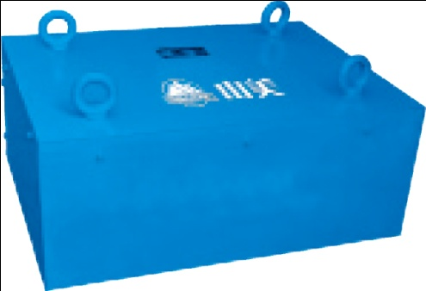

适用范围：
适用于皮带输送机、振动给料机、下料溜槽上的非磁性物料中除铁。
Applicable scope:
removal of iron in non-magnetic materials on belt conveyor, vibrating feeder and blanking chute.

技术参数 Technical Data:
型号  Model | 适应宽度  Belt width Adaptive(mm) | 悬挂高度  Suspension Height Rated(mm) | 适应带速  Belt Velocity(m/s) | 物料厚度  Material Thickness (mm) | 重量  Weight(kg) | 外型尺寸  Overall Dimensions(L×W×H)mm
RCYB-5 | 500 | 150 | 4.5 | 900 | 206 | 500 | 350 | 260
RCYB-6.5 | 650 | 200 | 4.5 | 150 | 450 | 650 | 600 | 300
RCYB-8 | 800 | 250 | 4.5 | 200 | 680 | 950 | 950 | 380
RCYB-10 | 1000 | 300 | 4.5 | 250 | 1180 | 1100 | 1000 | 380
RCYB-12 | 1200 | 350 | 4.5 | 300 | 1670 | 1300 | 1340 | 420
RCYB-14 | 1400 | 400 | 4.5 | 350 | 2350 | 1500 | 1500 | 420

RCYD系列永磁自卸式除铁器
RCYD Series Belt Permanent Magnetic Separator
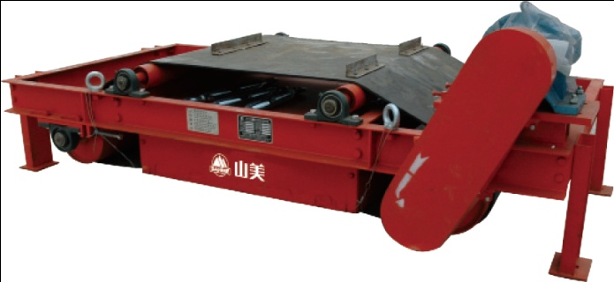

适用范围：
本机与各种皮带输送机、振动给料机等配套使用，可用于从运动的物料中自动吸除0.1-35kg的铁磁性物质。广泛应用于水泥、冶金、矿山、玻璃、煤炭等行业。
Applicable scope:
It is used together with belt conveyor, vibrating feeder, etc; applicable to automatic removal of 0.1-35kg ferro-magnetic materials from moving materials, and extensively applied in cement, metallurgy, mine, glass, coal and other industries.

技术参数 Technical Data:
型号  Model | 适用带宽  Belt width Adaptive  (mm) | 额定吊高  Suspension Height Rated  (mm) | 磁场强度  Magnetic Intensity SHR(mT) | 物料厚度  Material Thickness (mm) | 电机功率  Motor Power  (mw) | 适应带速  Belt Velocity(m/s) | 重量  Weight  (kg) | 外型尺寸  Overall Dimensions  (L×W×H)mm
RCYD-5 | 500 | 150 | 60 | 80 | 1.5 | 4.5 | 750 | 1900 | 735 | 935
RCYD-6.5 | 650 | 200 | 70 | 150 | 2.2 | 4.5 | 1200 | 2165 | 780 | 1080
RCYD-8 | 800 | 250 | 70 | 200 | 2.2 | 4.5 | 1400 | 2350 | 796 | 1280
RCYD-10 | 1000 | 300 | 70 | 250 | 3.0 | 4.5 | 2120 | 2660 | 920 | 1550
RCYD-12 | 1200 | 350 | 70 | 300 | 4.0 | 4.5 | 3350 | 2900 | 970 | 1720
RCYD-14 | 1400 | 400 | 70 | 350 | 4.0 | 4.5 | 4450 | 3225 | 1050 | 1980

