上海山美重型矿山机械有限公司是中国领先的破碎筛分设备制造商，是德国哈兹马克公司在中国的合资公司。拥有现代化的加工制造能力和由优秀的工程师组成的研发队伍，积多年的专业经验所开发的PP系列轮式移动破碎站具有国际先进水平，PP系列轮式移动破碎站在矿物加工、砂石骨料生产和建筑废物处理等领域得到广泛应用，并已经出口到世界上三十多个国家和地区。。

Shanghai Sanme Mining Machinery Co.,Ltd is a leading manufacturer of crushing and screening equipments in China, a joint venture with HAZEMAG Germany. Our company has modern manufacturing capability and excellent R&D teams of professional engineers. Based on our decades experience in crushing and screening field, PP Series Portable Crushing and Screening Plants have reached the international advanced level. PP Series Portable Crushing Plants are widely used in minerals processing, aggregates processing, construction waste recycling and other fields. They have been exported to more than 30 countries in the world.

PP系列轮式移动破碎站采用最新的移动破碎技术，能够完全满足客户的移动破碎要求，同固定式破碎设备相比较，能够大大降低客户的运营成本。
PP Series Portable Crushing Plants adopt the latest mobile crushing technology. They can fully meet customers’ different mobile crushing requirements. Compared with the stationary crushing plant, they can greatly reduce the customers’ operation cost.

PP系列轮式移动破碎站具有如下优异性能：
The Outstanding Performance of PP Series Portable Crushing Plants :

移动性强 Great Mobility :
PP系列轮式移动破碎站长度短，不同的破碎设备分别安装在独立的可移动底盘上，轴距短，转弯半径小，可以在普通公路上及作业厂区内灵活行驶。
PP Series Portable Crushing Plants are of short length. Different crushing equipment is separately installed on a separate mobile chassis. Its short wheelbase and tight turning radius mean they can be transported on highway and moved at crushing sites.

降低物料运输成本 Lower Transportation Cost :
PP系列轮式移动破碎站可以在现场加工物料，而不必将物料搬离现场再加工 ，大大地降低了物料的运输成本。
PP Series Portable Crushing Plants can crush materials on-site. It is unnecessary to carry the materials from one site and then crush them in another one, which can greatly lower the transporting cost for off-site crushing.

组合灵活，适应性强 Flexible Configuration and Great Adaptability:
PP系列轮式移动破碎站可根据不同的破碎工艺要求组成“先碎后筛”，也可组成“先筛后碎”流程，破碎站可按实际需求组合成粗碎、细碎两段破碎筛分系统，也可组合成粗碎、中碎、细碎三段破碎筛分系统，还可以独立运行，有很大的灵活性。
According to the different requirements of different crushing process, PP Series Portable Crushing Plants can form the following two processes of “crushing first, screening second” or “screening first, crushing second”. The crushing plant can be composed of two-stage plants or three-stage plants. The two-stage plants consists primary crushing plant and secondary crushing plant, while the three-stage plants includes primary crushing plant, secondary crushing plant and tertiary crushing plant, each of which is of high flexibility and can be used individually.

PP系列轮式移动破碎站具有如下设计特点：
The Design Features of PP Series Portable Crushing Plants :

移动底盘设计符合国际标准，拥有符合规范的灯光和制动系统。底盘采用大截面型钢，为重载设计。
Mobile chassis conforms to the international standards. It has standard lighting and braking system. The chassis is heavy-duty design with big section steel.

移动底盘采用U型梁设计，降低了移动站的整体高度，大大降低了破碎物料的装运成本。
The girder of mobile chassis is designed to be U style so that the overall height of the mobile crushing plant is reduced. So the loading cost is reduced greatly.

采用液压支腿（选装），便于现场安装；料仓采用组合设计，大大降低运输高度。
Adopt hydraulic leg(optional) for lift installation.Hopper adopt unitized design,reduce the transport height greatly.

PP系列移动颚式破碎站
PP Series Portable Jaw Crusher
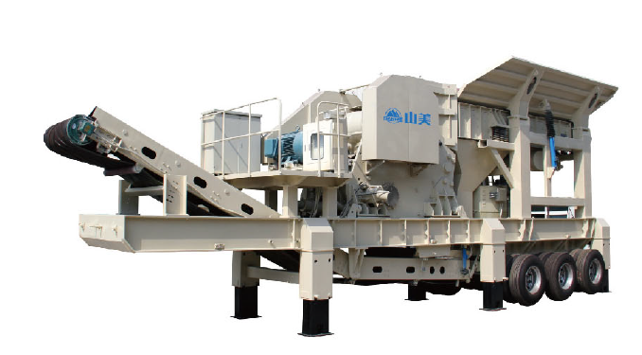
技术参数：
Technical Specifications:
PP系列移动颚式破碎站  PP Series Portable Jaw Crushers | PP600 | PP750 | PP900 | PP1060 | PP1200
运输尺寸 Transport dimensions
长 Length（mm） | 8600 | 9600 | 11097 | 13300 | 15800
宽 Width（mm） | 2520 | 2520 | 3759 | 2900 | 2900
高 Height（mm） | 3770 | 3500 | 3500 | 4440 | 4500
重量 Weight（kg） | 15240 | 22000 | 32270 | 57880 | 98000
轴重 Axle weight（kg） | 10121 | 14500 | 21380 | 38430 | 64000
牵引销荷重  King pin weight（kg） | 5118 | 7500 | 10890 | 19450 | 34000
颚式破碎机 Jaw Crusher
型号 Model | PE400x600 | PE500x750 | PE600X900 | PE750x1060 | PE900x1200
给料口  Feed opening（mm） | 400x600 | 500x750 | 600X900 | 750X1060 | 900x1200
出料口调整范围  Setting range(c.s.s)(mm) | 40-100 | 50-100 | 65-180 | 80-180 | 95-225
产量 Capacity（m3/h） | 10-35 | 25-60 | 30-85 | 70-150 | 100-240
给料机 Feeder
型号 Model | GZT0724 | GZT0724 | GZT0932Y | ZSW490x110 | ZSW600x130
料仓容积  Feed hopper volume（m3） | 3 | 4 | 7 | 10 | 10
料仓宽 Hopper width（mm） | 2200 | 2500 | 3000 | 3000 | 3000
皮带机 Belt Conveyor
型号 Model | B650×6 | B800×7 | B1000×8 | B1000×11 | B1200×13

