PF系列反击式破碎机
PF Series Impact Crusher
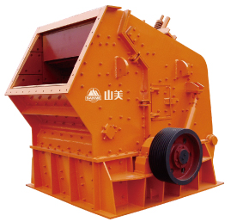

结构图 Structure Drawing
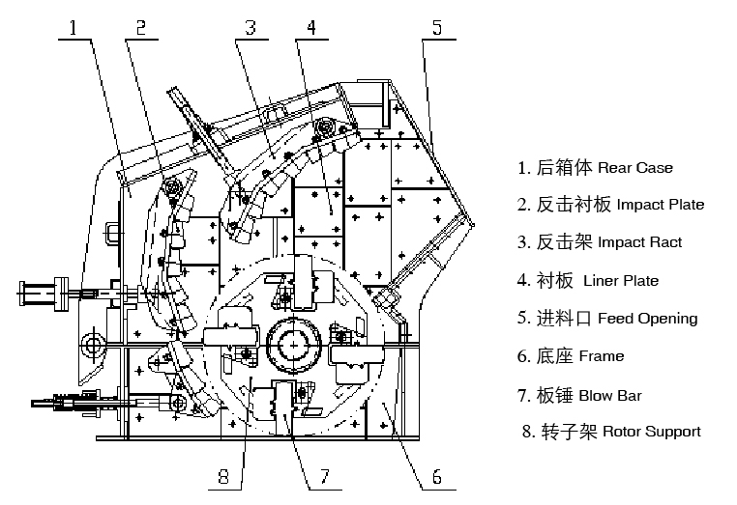

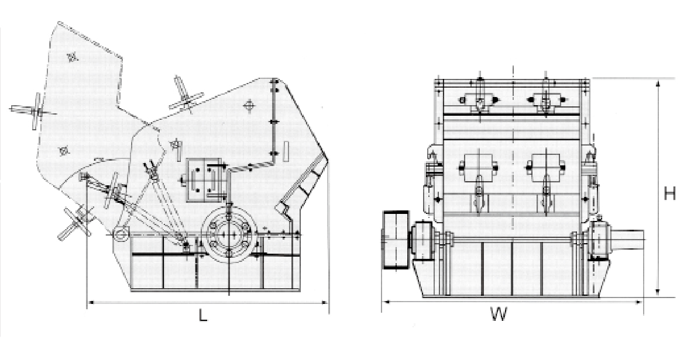
外形尺寸 Dimensions

PF系列反击式破碎机主要用于中碎，可破碎抗压强度不超过320Mpa的物料，适宜生产高等级公路、水电、建筑等行业用石料。
PF Series Impact Crusher is mainly used in secondary crushing, and can crush material its crushing compression strength not more than 320 Mpa. It is suitable to produce aggregate for highway, hydroelectric and building material industry,etc.

特点及优势 Features and Benefits:

◎ 多腔均匀破碎，适宜破碎硬岩；
◎ 均整板结构使排料更呈小粒径和立方体形，无内裂纹;
◎ 低矮的大进料口，便于生产线布置和增大进料尺寸;
◎ 全液压开启，便于维修及更换易损件;
◎ 新型耐磨材料使板锤、反击板和衬板使用寿命更长。
◎ Many cavity to crush, suitable for crushing hard rock.
◎ Reasonable design of leveling plate making charge finer and cubic without interior cracks.
◎ Low and big feed opening makes the production line easy to arrange and increase the size of feeding material.
◎ Use the hydraulic to open, easy to maintain and change wear-parts.
◎ New anti-abrasive material makes longer service life of impact bar, impact plate and liner.
技术参数 Technical Data:
型号  Model | 规格  Rotor Spec(mm) | 进料口尺寸  Feed Opening Size(mm) | 最大进料边长  Max Feed Edge(mm) | 生产能力（吨／小时）  Capacity(t/h) | 电机功率  Motor Power  (kw) | 外型尺寸  Overall Dimensions  (L×W×H)mm | 重量  Weight  (t)
PF-1007 | ∮1000×700 | 400×730 | 300 | 30-50 | 37-55 | 2400×1558×2660 | 9.5
PF-1010 | ∮1000×1050 | 400×1080 | 350 | 55-75 | 55-75 | 2400×2250×2620 | 12.2
PF-1210 | ∮1250×1050 | 400×1080 | 350 | 70-120 | 110-132 | 2690×2338×2890 | 14.9
PF-1214 | ∮1250×1400 | 400×1430 | 350 | 130-180 | 132-160 | 2690×2688×2890 | 18.6
PF-1310 | ∮1300×1050 | 490×1170 | 400 | 80-140 | 110-160 | 2780×2478×2855 | 16.2
PF-1315 | ∮1320×1500 | 860×1520 | 500 | 160-250 | 180-260 | 3096×3273×2667 | 19.3
PF-1415 | ∮1450×1500 | 1145×1520 | 950 | 220-450 | 220-315 | 3745×3022×3519 | 27
PF-1520 | ∮1520×2000 | 830×2050 | 700 | 300-550 | 315-440 | 3581×3560×3265 | 38.7
PF-1818 | ∮1800×1800 | 1600×1850 | 1000 | 600-850 | 650-900 | 4180×4200×4900 | 75

