PE.PEX系列颚式破碎机
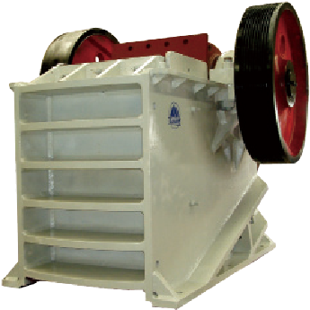
PE . PEX Series Jaw Crusher

PE、PEX系列颚式破碎机破碎比大、产品粒度均匀。用于破碎抗压强度不超过320Mpa的物料。
PE系列用于粗碎，PEX系列用于中、细碎。

PE,PEX Series Single Toggle Jaw Crusher has the features of great crushing ratio,uniform siges of promance. It can be used to crush material its compressive resistance not more than 320 Mpa.
PE series is used in primary crushing, PEX series is used in secondary crushing and fine crushing.

特点及优势 Features and Benefits:

◎结构简单、工作可靠
◎维修方便、运行费用经济
◎Simple structure and reliable operation
◎Convenient maintenance and low operation cost

技术参数 Technical Data:
型号  Model | 进料尺寸  Size of Feed Opening(mm) | 最大进料粒度  Max Feed Size(mm) | 排料口调整范围  Discharge Range Opening(mm) | 处理能力  Capacity(m³/h) | 电机功率  Motor Power(kw) | 重量  Weight(t)
PE-400×600 | 400×600 | 340 | 40-100 | 10-35 | 30 | 6.5
PE-500×750 | 500×750 | 425 | 50-100 | 25-60 | 55 | 10.6
PE-600×900 | 600×900 | 500 | 65-180 | 30-85 | 55-75 | 15.5
PE-750×1060 | 750×1060 | 630 | 80-180 | 72-150 | 90-110 | 28
PE-800×1060 | 800×1060 | 680 | 100-200 | 85-143 | 90-110 | 30
PE-870×1060 | 870×1060 | 750 | 170-270 | 145-235 | 90-110 | 30.5
PE-900×1200 | 900×1200 | 780 | 95-225 | 100-240 | 110-132 | 49
PE-1000×1200 | 1000×1200 | 850 | 195-280 | 190-275 | 110-132 | 51
PE-1200×1500 | 1200×1500 | 1020 | 150-300 | 250-500 | 160 | 100.9
PEX-250×1000 | 250×1000 | 210 | 25-60 | 10-32 | 30-37 | 6.5
PEX-250×1200 | 250×1200 | 210 | 25-60 | 13-38 | 37 | 7.7
PEX-300×1300 | 300×1300 | 250 | 20-90 | 10-65 | 75 | 11
注：处理能力为加工中硬物料、破碎物料松散密度为1.6×10³kg/m³时的数据。
Note:The processing capacity is described on the basis of data about processing mid-hard materials and the bulk density of crushed materials is 1.6t/m³

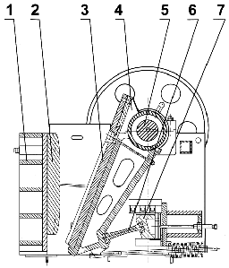
结构图 Structural Drawing

1. 机架 Frame
2. 固定颚板 Fixed Jaw plate
3. 活动颚板 Movable Jaw Plate
4. 动颚 Movable Jaw
5. 偏心轴 Eccentric Shaft
6. 肘板 Toggle
7. 调整板 Adjusting Toggle Seat

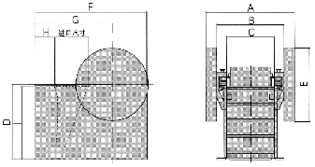
外形尺寸 Overall Dimensions

外形尺寸(mm) Overall Dimensions
型号 Model | A | B | C | D | E | F | G | H | I
PE-400×600 | 1732 | 1110 | 636 | 1105 | 962 | 1565 | 955 | 255 | 990
PE-500×750 | 1916 | 1256 | 820 | 1270 | 1200 | 1890 | 1370 | 435 | 1185
PE-600×900 | 1840 | 1400 | 960 | 1540 | 1515 | 2305 | 1590 | 390 | 1505
PE-750×1060 | 2472 | 1820 | 1060 | 2010 | 1660 | 2450 | 1850 | 530 | 1980
PE-800×1060 | 2556 | 1780 | 1060 | 1970 | 1660 | 2610 | 2010 | 585 | 1840
PE-870×1060 | 2556 | 1780 | 1060 | 1970 | 1660 | 2660 | 2060 | 585 | 1840
PE-900×1200 | 3182 | 1976 | 1200 | 2125 | 1800 | 3335 | 2155 | 830 | 2530
PE-1000×1200 | 3182 | 1976 | 1200 | 2125 | 1800 | 3435 | 2255 | 830 | 2530
PE-1200×1500 | 3732 | 1780 | 1620 | 2700 | 2285 | 4200 | 2940 | 970 | 3480
PEX-250×1000 | 1992 | 1500 | 1010 | 930 | 900 | 1530 | 905 | 330 | 850
PEX-250×1200 | 2192 | 1700 | 1220 | 930 | 1000 | 1900 | 965 | 365 | 850
PEX-300×1300 | 2320 | 1840 | 1320 | 1110 | 1228 | 1750 | 1170 | 430 | 930

