上海山美重型矿山机械有限公司是中国领先的破碎筛分设备制造商，是德国哈斯玛克公司在中国的合资公司。目前能够给客户提供全系列破碎筛分设备和完整解决方案，产品包括颚式破碎机、圆锥破碎机、反击式破碎机、立式冲击破碎机（制砂机）、振动筛、细砂回收系统、轮式移动破碎站和履带式移动破碎站。我们的目标是为全球客户提供值得信赖的产品和服务，为客户创造价值。

Shanghai Sanme Mining Machinery Co., Ltd is a leading manufacturer of crushing and screening equipments in China. Sanme is a joint venture with Hazemag Germany. we not only can offer full range of crushing and screening equipments, including jaw crusher, cone crusher, impacter, VSI, screen, fine sand collecting system, mobile crushing and screening plants, but also provide total solutions. Our aim is to provide reliable products and services for global customers and create values for our customers.

欧星MP-VSI系列履带移动立式冲击破碎站
MP-VSI Series Mobile VSI Crushing Plants

欧星MP-VSI系列履带移动立式冲击破碎站采用德国技术设计和制造，达到了国际先进水平，在设计中广泛采用了世界上最先进的移动破碎技术，能够完全满足客户的移动破碎要求，改变您的盈利模式。

Designed and manufactured with German technology, MP-VSI Series Mobile VSI Crushing Plants has reached the world advanced level. The plant adopts first level mobile crushing technique, which fully meets the customers' requirement of high mobility, high crushing efficiency and optimizes your business mode.

欧星MP-VSI系列履带移动立式冲击破碎站可以应用于：
MP-VSI Series Mobile VSI Crushing Plants is applicable for:

- 矿物和硬岩破碎 Minerals and hard rock crushing
- 制砂和整形 Make sand and aggregate shaping
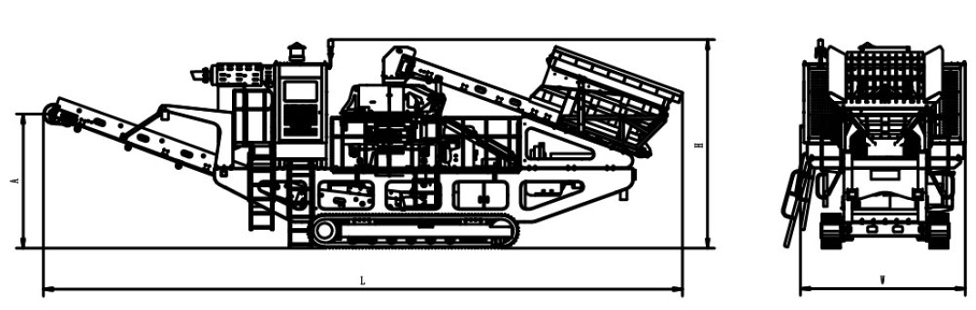

技术参数：
Technical Specifications:
欧星MP-VSI系列履带移动立式冲击破碎站  MP-VSI Series Mobile VSI Crushing Plants | MP-VSI 5000 |  | MP-VSI 6000 | MP-VSI 7000
立式冲击破碎机型号 VSI Crusher | VSI 5000 |  | VSI 6000 | VSI 7000
最大进料粒度 Max Feed Size(mm) | 65 |  | 70 | 70
处理量 Crushing Capacity(t/h) | 80-150 |  | 120-250 | 180-350
动力装置 Driving Unit
发动机 Engine | Cummins or CAT |  | Cummins or CAT | Cummins or CAT
功率 Performance（kw） | 400 |  | 480 | 550
给料斗 Feed Hopper
料斗容积 Hopper Volume（m³） | 4 |  | 6 | 6
带式给料机 Belt Feeder
驱动方式 Drive | 液压 hydraulic |  | 液压 hydraulic | 液压 hydraulic
主皮带机 Main Conveyor belt
卸料高度 Discharge Height（mm） | 2900 |  | 3300 | 3300
驱动方式 Drive | 液压 hydraulic |  | 液压 hydraulic | 液压 hydraulic
履带行走装置 Crawler Unit
驱动方式 Drive | 液压 hydraulic |  | 液压 hydraulic | 液压 hydraulic
外形尺寸和重量 Dimensions and Weight
工作状态外形尺寸 Working Dimensions
-长度 Length（mm） | 13767 |  | 13940 | 13940
-宽度 Width（mm） | 3621 |  | 3820 | 3920
-高度 Height（mm） | 4425 |  | 4980 | 4980
运输状态外形尺寸 Transport Dimensions
- 长度 Length（mm） | 14273 | 14320 |  | 14320
- 宽度 Width（mm） | 3543 | 3751 |  | 3851
- 高度 Height（mm） | 4024 | 4130 |  | 4330
重量 Weight（t） | 38 | 43 |  | 47

注：上述生产能力是在破碎物料堆比重为1.6t/m³时开路循环生产中总吨数。生产能力与破碎物料的物理性能、给料方式、进料粒度及其组成等工况有关。
Note: Capacity is total tons per hour passing through crusher at open circuit when bulk density of feeding is 1.6t/m³. Capacities are relative to physics character and type of feeding, feeding size and composition.

