上海山美重型矿山机械有限公司是中国领先的破碎筛分设备制造商，是德国哈兹马克公司在中国的合资公司。拥有现代化的加工制造能力和由优秀的工程师组成的研发队伍，公司自成立以来始终坚持对新产品、新技术的大力研发，使开发的产品具有国际先进水平，目前能够给客户提供全系列破碎筛分设备和完整解决方案，产品包括颚式破碎机、圆锥破碎机、反击式破碎机、立式冲击破碎机（制砂机）、振动筛、细砂回收系统、轮式移动破碎站和履带式移动破碎站。我们的产品在矿物加工、砂石骨料生产、建筑废物回收、钢渣处理、隧道破碎、和水泥行业等领域得到广泛应用，并已经出口到世界上三十多个国家和地区。我们的目标是为全球客户提供值得信赖的产品和服务，为客户创造价值。

Shanghai Sanme Mining Machinery Co., Ltd is a leading manufacturer of crushing and screening equipments in China. Sanme is a joint venture with Hazemag Germany, With modern manufacturing capability and excellent R&D teams of professional engineers, we have devoted ourselves all the time to research and develop new products and technologies since its establishment, which make our developed products achieve advanced world standard. we not only can offer full range of crushing and screening equipments, including jaw crusher, cone crusher, impacter, VSI, screen, fine sand collecting system, mobile crushing and screening plants, but also provide total solutions. Our products are widely applied in the fields of mineral processing, aggregate processing, construction waste recycling ,steel slag processing,tunnel crushing,and cement industries and so on, meanwhile, they have exported to more than 30 countries and regions in the world. Our aim is to provide reliable products and services for global customers and create values for our customers.

欧星MP-J系列履带移动颚式破碎站
MP-J Series Mobile Jaw Crushing Plants
欧星MP-J系列履带移动颚式破碎站采用德国技术设计和制造，达到了国际先进水平，在设计中广泛采用了世界上最先进的移动破碎技术，能够完全满足客户的移动破碎要求，改变您的盈利模式。

Designed and manufactured with Germany technology, MP-J Series Mobile Jaw Plant has reached the world advanced level. The plant adopts first level mobile crushing technique, which fully meets the customers' requirement of high mobility, high crushing efficiency and optimizes your business mode.

欧星MP-J系列履带移动颚式破碎站具有如下特点： Characteristics:
- 破碎效率高，处理量大 ◆ High capacity and crushing efficiency
- 重型化设计，高可靠性 ◆ Heavy duty design, high reliability
- 易于运输和能够快速投入生产 ◆ Easy transport and fast set-up
- 操作和维护方便 ◆ Convenient operation and maintenance
- 移动灵活 ◆ High mobility
- 发动机先进，油料消耗低，大大降低运营成本 ◆ Advanced engine, less fuel consumption, reduces operation cost
- 符合最严格的环保标准 ◆ Meet strict environmental standards

欧星MP-J系列履带移动颚式破碎站采用如下世界著名品牌产品：
MP-J Series Mobile Jaw Plant purchase from world famous brand:
康明斯或卡特彼勒发动机（选装） Cummins or CAT Engine（Optional）
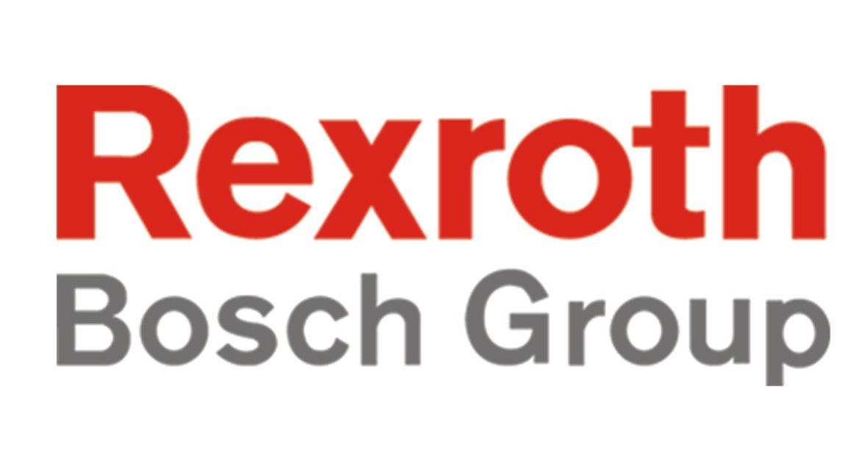
力士乐液压泵（选装） Rexroth Hydraulic Pump（Optional）
瑞典品牌SKF轴承（选装） SKF Bearing（Optional）

欧星MP-J系列履带移动颚式破碎站可以应用于：
MP-J Series Mobile Jaw Crushing Plants is applicable for:
- 矿物和硬岩破碎 ◆ Minerals and hard rock crushing
- 砂石骨料生产 ◆ Aggregate processing
- 建筑废物回收 ◆ Construction waste recycling
- 钢渣处理 ◆ Slag processing
- 隧道破碎 ◆ Tunnel crushing
- 水泥原料加工 ◆ Cement Industry

欧星MP-J系列履带移动颚式破碎站
MP-J Series Mobile Jaw Crushing Plants

外形尺寸：
Dimensions(mm):
 | MP-J6 | MP-J7 | MP-J8 | MP-J10
L | 12600 | 14800 | 16000 | 16500
W | 4060 | 4100 | 4800 | 6500
H | 4160 | 4400 | 4400 | 6000
A | 2900 | 3300 | 3800 | 4000
B | 2140 | 2400 | 3000 | 3200
C | 2760 | 2850 | 3250 | 4300

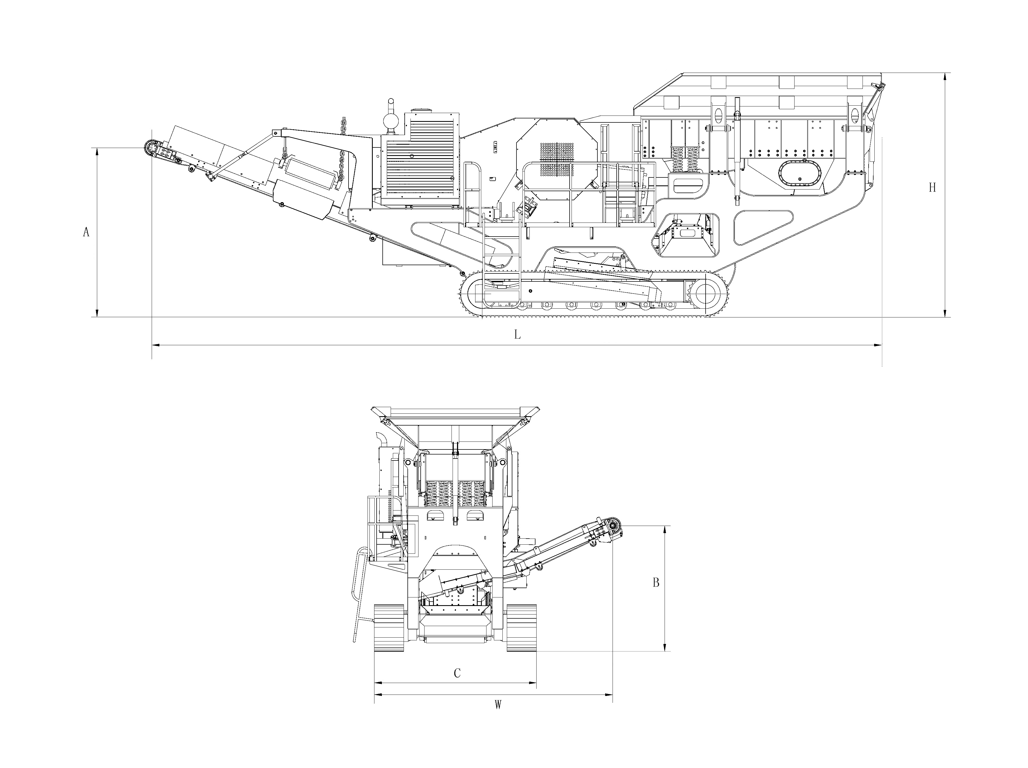
技术参数：
Technical Specifications:
颚式破碎机型号 Jaw Crusher | MP-J6 | MP- J7 | MP- J8 | MP- J10
进料口尺寸 Size of Feed Opening(mm×mm) | 600×1060 | 760×1000 | 850×1150 | 1070×1400
最大进料粒度 Max Feed Size(mm) | 500 | 630 | 720 | 950
排矿口调整范围Gap Width(mm) | 60-175 | 70-200 | 70-220 | 100-250
处理量Crushing Capacity(t/h) | 最大 up to 280 | 最大 up to 400 | 最大 up to 500 | 最大 up to 800
动力装置 Driving Unit
发动机 Engine | Cummins Tier3 | Cat C9 | Cat C12 | Cat C15
功率 Performance（kw） | 164 | 242 | 317 | 390
给料斗 Feed Hopper
料斗容积 Hopper Volume（m³） | 6 | 7 | 8 | 10
棒条给料机 Grizzly Feeder with Pre-screening
驱动方式 Drive | 液压 hydraulic | 液压 hydraulic | 液压 hydraulic | 液压 hydraulic
主皮带机 Main Conveyor belt
皮带宽度 Belt Width（mm） | 1000 | 1000 | 1200 | 1400
卸料高度 Discharge Height（mm） | 2900 | 3300 | 3800 | 4000
驱动方式 Drive | 液压 hydraulic | 液压 hydraulic | 液压 hydraulic | 液压 hydraulic
侧皮带机 Side Conveyor Belt
卸料高度 Discharge Height(mm) | 2140 | 2400 | 3000 | 3200
驱动方式 Drive | 液压 hydraulic | 液压 hydraulic | 液压 hydraulic | 液压 hydraulic
运输时皮带机头部可以折叠 For transportation the head-piece can be folded
履带行走装置 Crawler Unit
驱动方式 Drive | 液压 hydraulic | 液压 hydraulic | 液压 hydraulic | 液压 hydraulic
永磁自卸式除铁器 Permanent Magnetic Separator
除铁器 Magnetic Separator | 可选option | 可选option | 可选option | 可选option
外形尺寸和重量 Dimensions and Weights
工作状态外形尺寸 Working Dimensions
-长度 Length(mm) | 12600 | 14800 | 16000 | 16500
-宽度 Width(mm) | 4060 | 4100 | 4200 | 4300
-高度 Height(mm) | 4160 | 4400 | 4400 | 6000
运输状态外形尺寸 Transport Dimensions
- 长度 Length(mm) | 12600 | 14600 | 16000 | 16000
- 宽度 Width(mm) | 2760 | 2850 | 3200 | 3500
- 高度 Height(mm) | 3460 | 3900 | 3800 | 3900
重量 Weight(t) 约Approximately | 39 | 48 | 65 | 115

注：上述生产能力是在破碎物料堆比重为1.6t/m³时开路循环生产中总吨数。生产能力与破碎物料的物理性能、给料方式、进料粒度及其组成等工况有关。
Note: Capacity is total tons per hour passing through crusher at open circuit when bulk density of feeding is 1.6t/m³. Capacities are relative to physics character and type of feeding, feeding size and composition.

