欧星HC系列反击式破碎机
HC Series Impact Crusher
产量更高 Higher Capacity
运行成本更低 Lower Operation Cost
创造更大价值 Larger Valuability

上海山美重型矿山机械有限公司是德国哈兹马克公司在中国的合资企业，哈兹马克公司成立于1946年，其创始人安德鲁博士是反击式破碎机的发明者。山美积多年经验研发的HC系列反击式破碎机具有世界先进水平，对破碎腔进行了优化，转子采用重型化设计，改进了板锤的固定装置，使得板锤固定的可靠性更高，增加了人性化的设计，使维修更方便。

Shanghai Sanme Mining Machinery Co., Ltd is a subsidiary of HAZEMAG Germany JV company in China. HAZEMAG &EPR GmbH was founded in 1946 by the inventor of impact crusher Dr. Andreas. By many years experience, Sanme has developed the HC Series Impact Crushers with world advanced level. The crushing chamber is optimized, the rotor is designed in heavy duty, and the fixing device of blow bar is improved to provide a higher reliablity degree. Humanized design makes the maintenance more convenient.

欧星HC系列反击式破碎机即可用于物料的粗碎，也可用于中碎和细碎。主要应用于砂石骨料加工、水泥行业的生料破碎、建筑废物回收等领域。

HC Series Impact Crushers can be used in primary, secondary and tertiary crushing stages. They are mainly applied in the field of aggregates, cement and recycling industry.

欧星HC系列反击式破碎机特点及优势：
HC Series Impact Crusher Features:

优化的腔型 更高的产量 Optimized crushing chamber, higher capacity
HC系列反击式破碎机对破碎机的腔型进行了优化，可以大大提高产量，可以实现大破碎比，从而减少投资。
The crushing chamber of HC series impact crushers is optimized, which obtains extra capacity, improves crushing reduction and lower your capital costs.

大进料口设计，可以破碎更大的物料 Bigger feed opening design, bigger material crushed
HC系列反击式破碎机通过优化，加大了进料口设计，可以破碎更大的物料，在破碎石灰石等中硬物料时，可以代替颚式破碎机。特别是处理进料粒度较大的钢筋混凝土等建筑垃圾时，更具优势。
By optimization, HC series impact crushers use enlarged feed opening design, which can crush bigger material. When crushing medium hard material eg. Limestone, they can replace jaw crusher. Especially in crushing oversized concrete in the construction waste, they have more advantges.

增加研磨腔设计（可选），使应用范围更广 Adding grinding cavity design (Optional), wide application
HC系列反击式破碎机通过增加研磨腔的设计，可实现大破碎比，使排料更小、产品粒形更优。给客户更多选择，扩大了应用范围。
With the design of grinding cavity, HC series impact crusher achieves bigger crushing ratio, lower discharge opening and excellent product shape. More choice for customers makes more application.
转子重型化设计，改进板锤固定方式，增加了可靠性
Heavy rotor design and unique blow bar fixing system provide reliability
HC系列反击式破碎机转子采用重型化设计，不但提高了可靠性，还提高了转子的转动惯量，可以提高破碎机的处理能力；改进了板锤的固定方式，使板锤的更换更方便，固定更可靠。
HC series impact crushers adopt heavy rotor design, which not only improves reliability, but also increases moment of inertia of rotor and capacity. The fixing of blow bar is improved to make the exchange easy and fixing reliable.

可靠的过载和过铁保护装置 Reliable overload and tramp iron protection device
HC系列反击式破碎机为了保护转子主体和板锤，优化了过载和过铁保护装置，反击板在过载的情况下可以回缩，一旦载荷值恢复正常，反击板会回到预设位置并正常工作。
For the protection of the rotor body and blow bars, the HC series impact crushers optimize overload and tramp iron protection device. The impact aprons retract under excessive load. As soon as the load value returns to normal, the impact aprons resumes its pre-set position, and operation continues without interruption.

方便维护，安全可靠 Easy to maintain, high reliability and safety
HC系列反击式破碎机采用液压助力设计，大大方便调整排矿口，便于打开上机架进入破碎机内部进行检查、维修和更换。
The hydraulic power unit is used by HC series impact crusher for easy adjustment of setting. It is convenient for checking, maintaining and changing wear parts.

结构图 Structure Drawing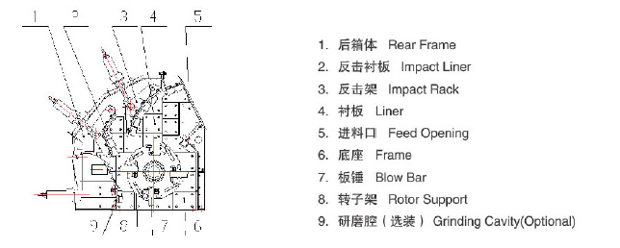
外形尺寸 Overall Dimensions
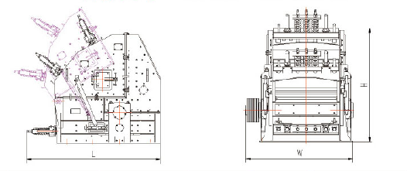

技术参数：
Technical Specifications:
型号  Model | 进料口尺寸  Feed Opening | 最大进料边长  Max Feed Size | 生产能力 Capacity（t/hr） | 电机功率 Power | 外型尺寸  Overall Dimensions (LXWXH) | 重量(不含电机)  Weight（Excluding Motor）(t)
HC128(A) | 780×630 | 300 | 50-130 | 55-90 | 2890(3058)×1748×2932 | 10.8
HC139(A) | 1100×630 | 400 | 130-210 | 90-132 | 2890(3058)×2048×2932 | 13.6
HC239(A) | 1100×740 | 500 | 180-280 | 110-160 | 2926(3095)×2048×2864 | 14.7
HC255(A) | 1450×760 | 500 | 200-300 | 160-200 | 2893(3095)×2398×2970 | 17.4
HC359(A) | 1550x1070 | 700 | 220-330 | 200-250 | 3700x3025x3240 | 25.7
HC459(A) | 1550x1130 | 750 | 300-460 | 250-315 | 3750(3754)x3022x3330 | 27.1
HC579(A) | 2050×830 | 800 | 320-490 | 400-440 | 3582×3561×3266 | 36.3
HC679(A) | 2050x1230 | 1100 | 480-750 | 400-440 | 3900x3600x3500 | 50.5
HC779(A) | 2050x1670 | 1500 | 500-850 | 630 | 4770x4338x4849 | 78.9
HC887(A) | 2540x1845 | 1600 | 800-1200 | 1000 | 5355x5399x5454 | 111.5
注：“A”表示带研磨腔，为选装。
上述生产能力是在破碎物料堆比重为1.6t/m3时开路循环生产中总吨数。生产能力与破碎物料的物理性能、给料方式、进料粒度及其组成等工况有关。
Note:“A”shows grinding cavity, optional.
Capacity is the total production tons of open circuit when the material bulk density to be crushed is 1.6t/m³. Production capacity will be affected by physics character of material and feeding method, feeding size and material composition, and so on.

粒度特性曲线 Gradation Curves
