GZT系列棒条振动给料机
GZT Series Vibrating Feeder
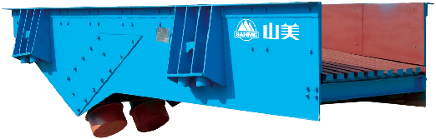

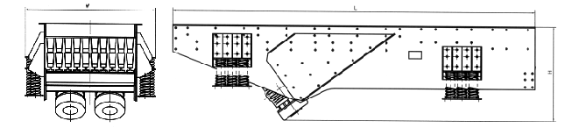

GZT系列棒条振动给料机系消化吸收瑞典技术设计制造，并采用引进日本技术生产的振动电机为激振源。该系列给料机用于粗碎破碎机前大块物料的均匀给料，同时由于棒条筛面的作用，又能除掉泥土等细碎物料，达到预筛分功能，能够提高粗碎能力。特别适用于水电行业，建筑石料，金属矿石等粗碎前的给料用。

GZT Series Vibrating Feeder adopts the vibrating motor to produce vibration force . it is used to feed material into the primary crusher homogeneously, meanwhile because of the bar-shaped screen, it can screen away soil contained in the raw material, increase the capacity of the primary crushing. It is suitable for feeding material into the primary crusher in hydropower field, building material and mining.

特点及优势 Features and Benefits:

◎ 该机结构简单，使用维护方便。
◎ Simple structure and reliable operation

技术参数 Technical Data:
型号  Model | 最大进料粒度  Max Feed Size(mm) | 处理能力  Capacity(t/h) | 电机功率  Motor Power(kw) | 棒条倾角  Installation Slope(⁰ ) | 双振幅  Double Amplitude(mm) | 外型尺寸  Overall Dimensions(LxWxHmm) | 重量  Weight(kg)
GZT-0724 | 450 | 30-80 | 2×1.5 | 10 | 4-6 | 2481×1130×990 | 2422
GZT-0932 | 560 | 80-150 | 2×2.4 | 10 | 4-8 | 3298×1512×1195 | 2440
GZT-0940 | 560 | 80-180 | 2×3.7 | 10 | 4-8 | 4100×1818×1134 | 3700
GZT-1148 | 600 | 150-300 | 2×5.5 | 10 | 4-8 | 4926×1676×1475 | 5060
GZT-1256 | 800 | 180-400 | 2×7.5 | 10 | 4-8 | 5704×1840×1492 | 6385
GZT-1560 | 1000 | 400-600 | 2×13 | 10 | 4-8 | 6110×2440×1560 | 8900

