CXFL系列粗细粉分离机
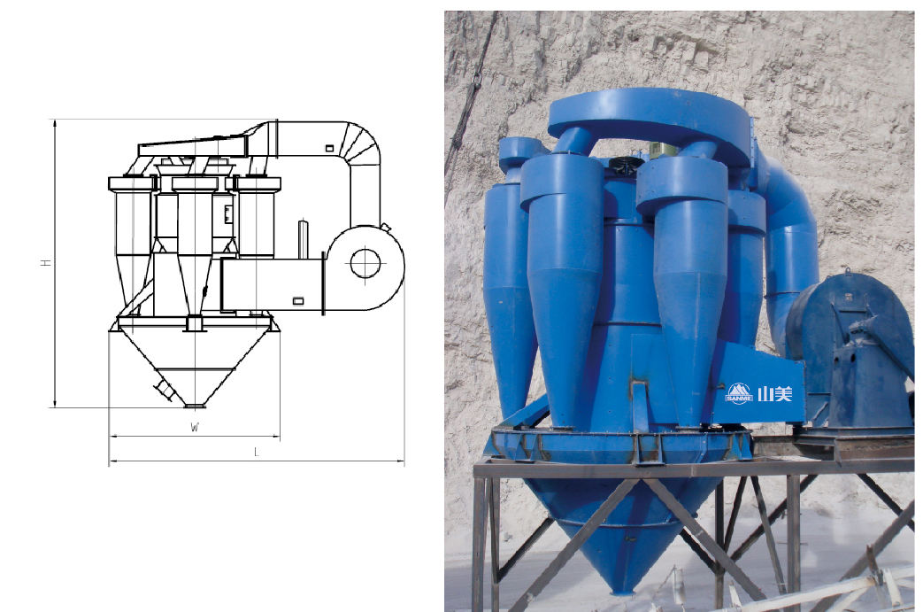
CXFL Series Powder Separator

CXFL系列粗细粉分离机是参照美国技术而研制的，专门用于机制砂干法生产工艺中超标石粉的分离，可以非常方便地控制机制砂中石粉的含量，以满足客户的不同要求。

The CXFL Series Powder separator is based on American technology. It is an ideal equipment to separate powder from manufactured sand for dry way. It is very easy to control the powder ingredient of manufactured sand and meet different requirements of the clients.

技术参数 Technical Data:
型号  Model | 主轴转速  Major Axis Speed(r/min) | 生产能力  Capacity(t/h) | 主轴电机功率  Motor Power(kw) | 风机电机功率  Fan Motor Power(kw)
CXFL-2000 | 190-380 | 20-35 | 11 | 30
CXFL-3000 | 150-350 | 30-45 | 15 | 37
CXFL-3500 | 130-320 | 45-55 | 18.5 | 55
CXFL-4000 | 120-280 | 55-75 | 30 | 90
CXFL-5000 | 120-280 | 75-100 | 55 | 132

